CEEPUS network application:
- HOW TO add a new contact person for a Participating Unit (PPU)
- HOW TO generate CEEPUS documents (LoI, LoE)
Each Participating Unit in a CEEPUS network needs a main contact person.
The main contact Person of a PPU has to forward all mobility applications concerning this unit.
If you want to change the main contact person for a participating unit in your network application, the person has to register under My CEEPUS for managing a CEEPUS network first.
See our Guideline “How to register” for further information:
During a running academic year only the technical support can change a contact person.
Coordinators can change a contact person in the new application form before submitting.

Choose a unit from the prolonged network application or add a new one by pressing +:
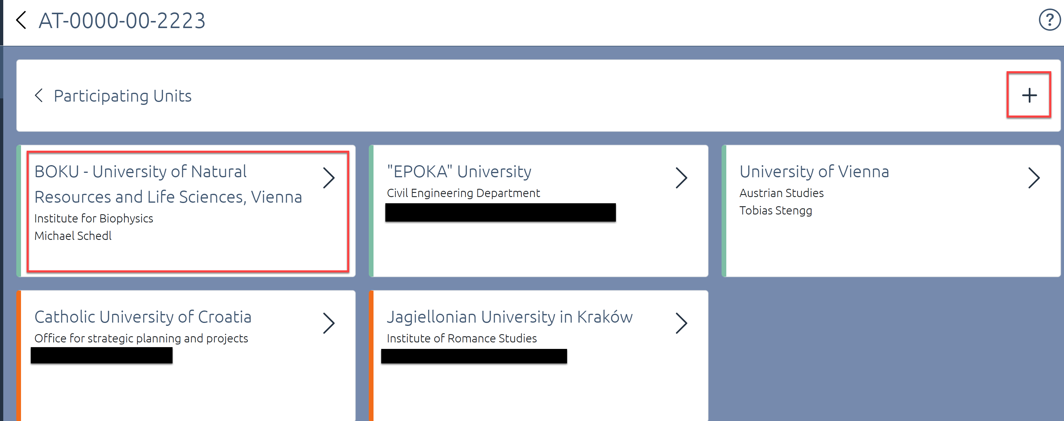

Make sure that you choose the correct unit:
If the unit is not on the list, the registration of your new contact person was not done properly. Get In contact with the National CEEPUS Office for further advise.

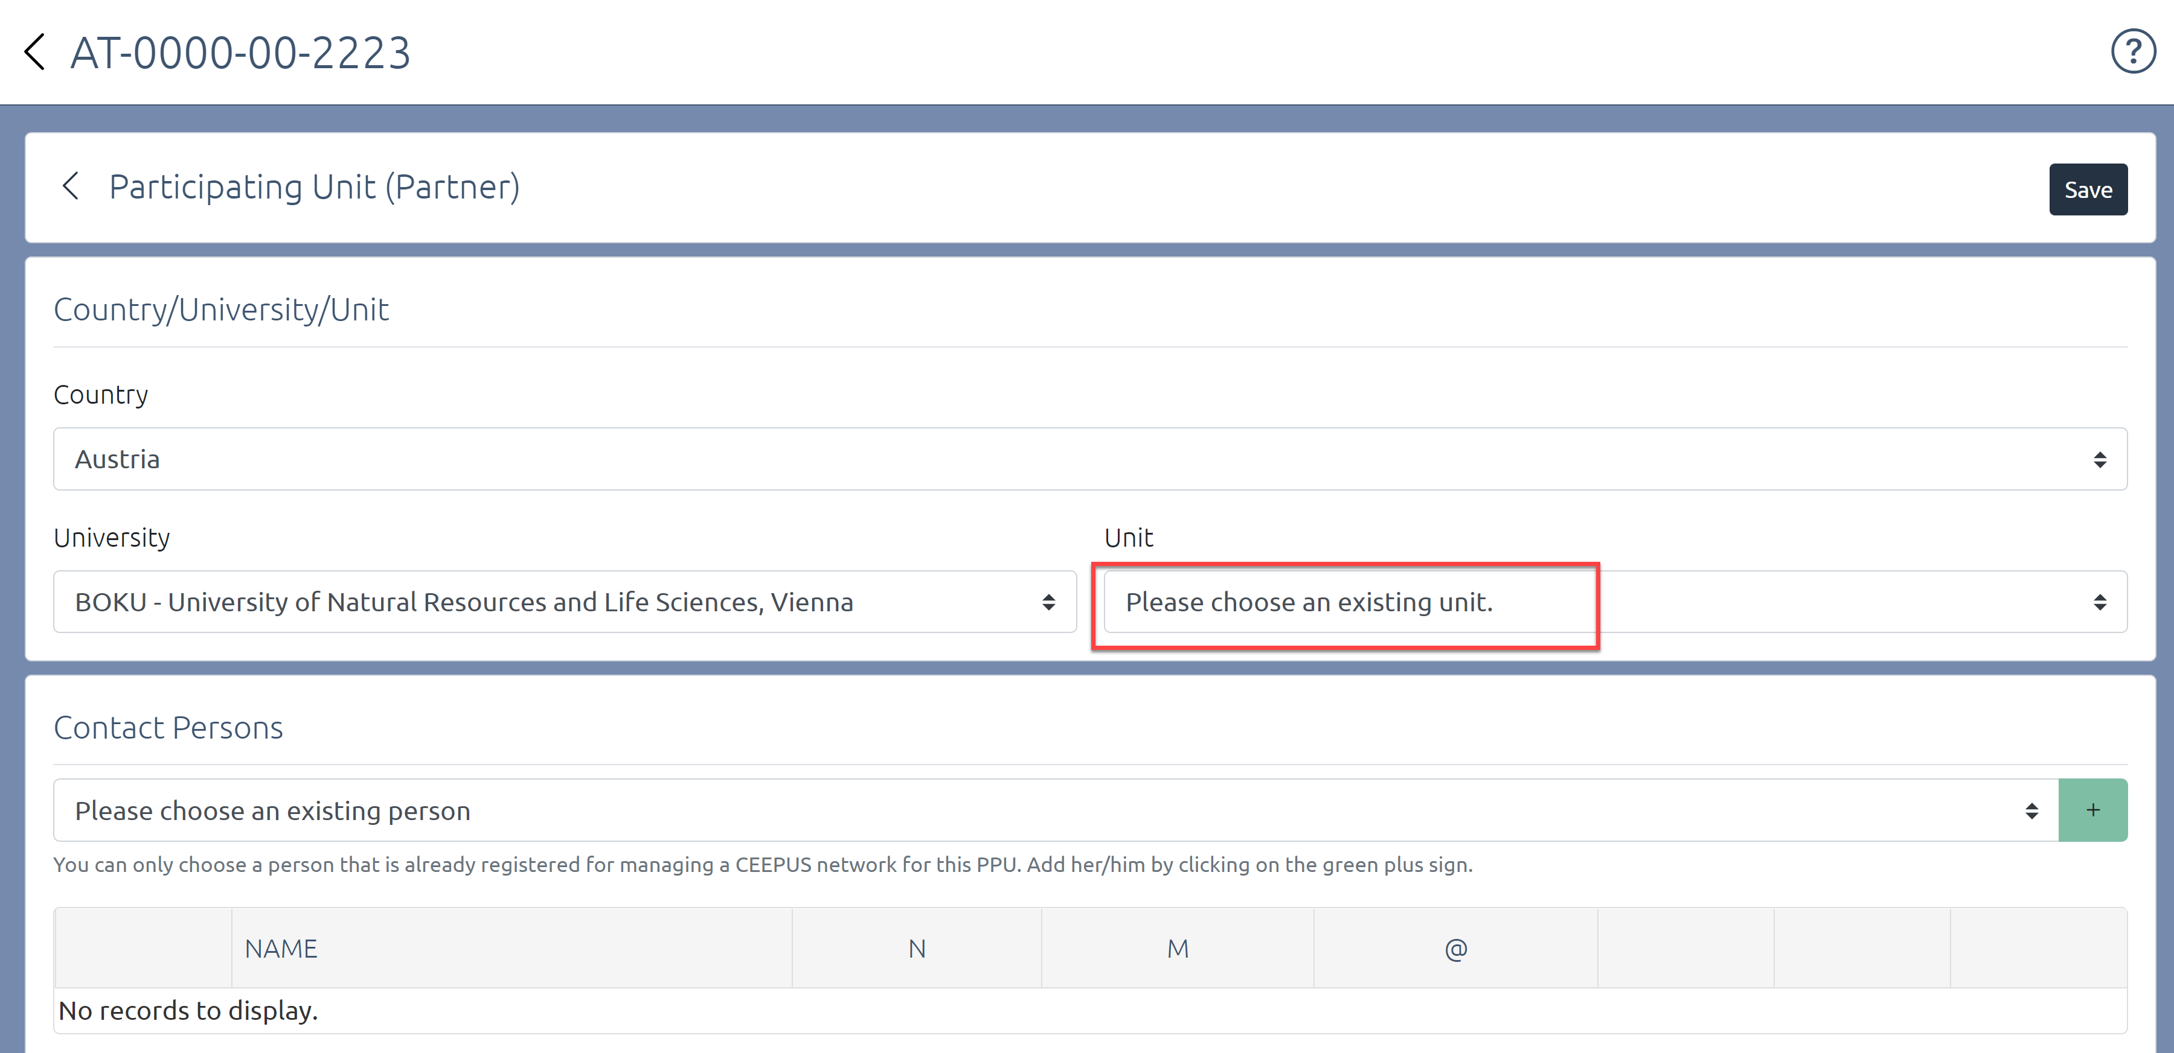

Choose a person from the list of registered contact persons: Press the green “+”
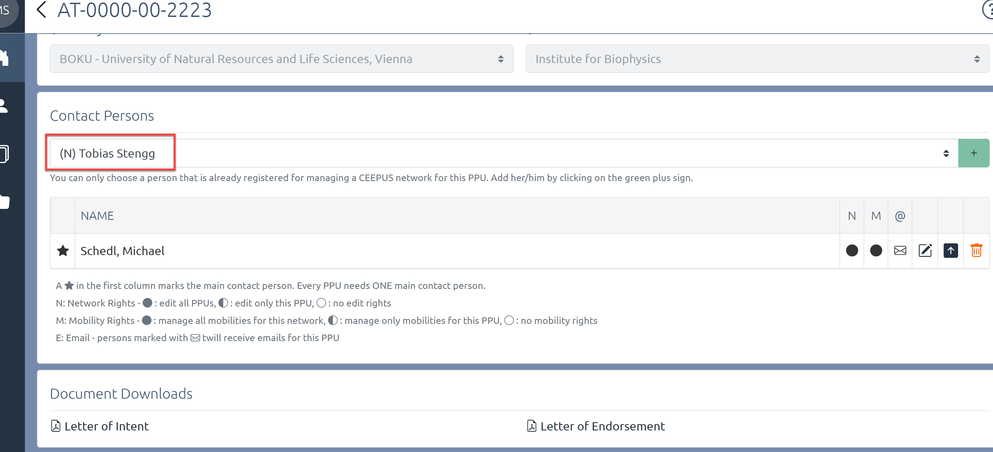

Activate the E-Mail to receive E-Mails for this unit:
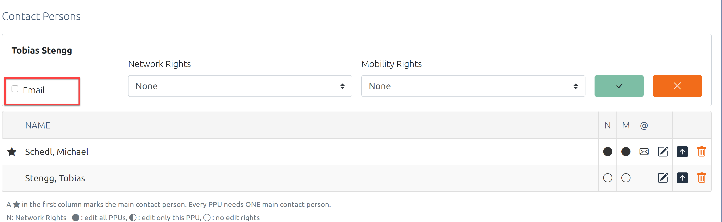

You can assign Network Rights and mobility rights to each contact person:
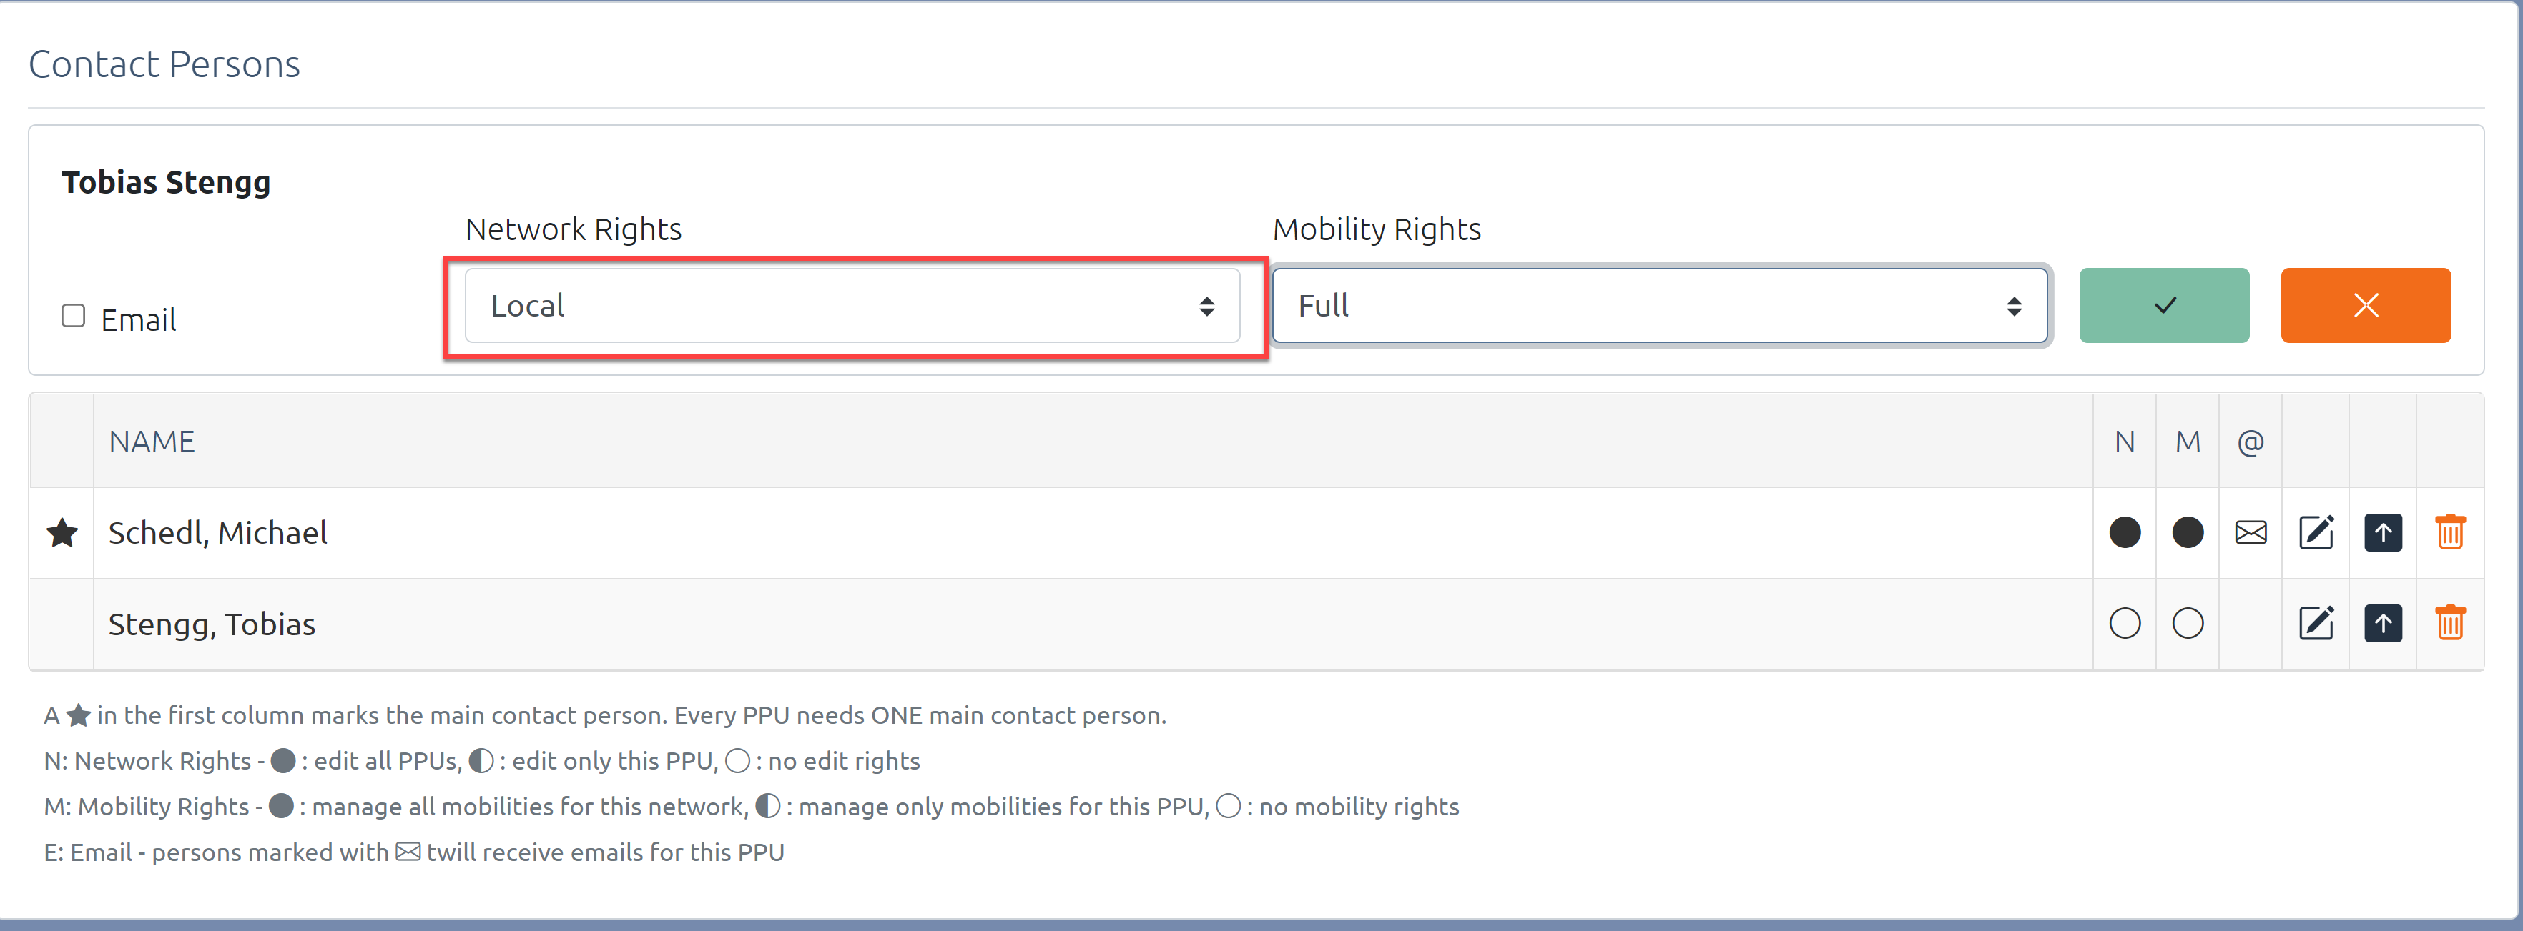

Only coordinators can get full network rights
Partner Units can only get local rights.
Confirm your setting:
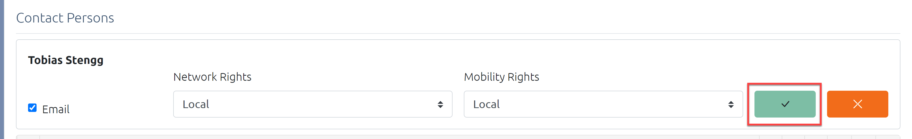

The person is now on your list.
The star indicates your main contact person for this unit
Use the arrow to change the main contact:
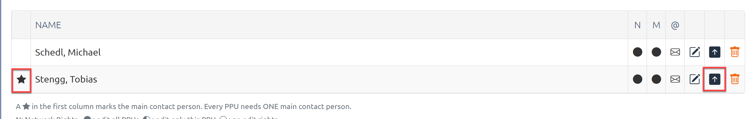

You can now generate new CEEPUS documents for the main contact person:
Letter of Intent and Letter of Endorsement
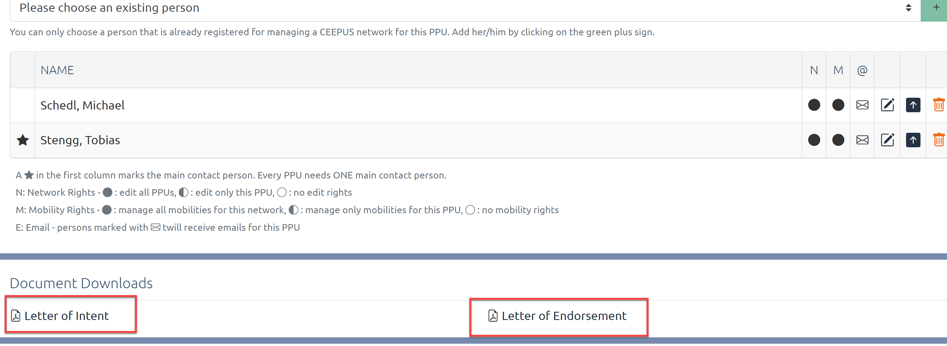

Print out the documents, have them signed, scan and upload them again:

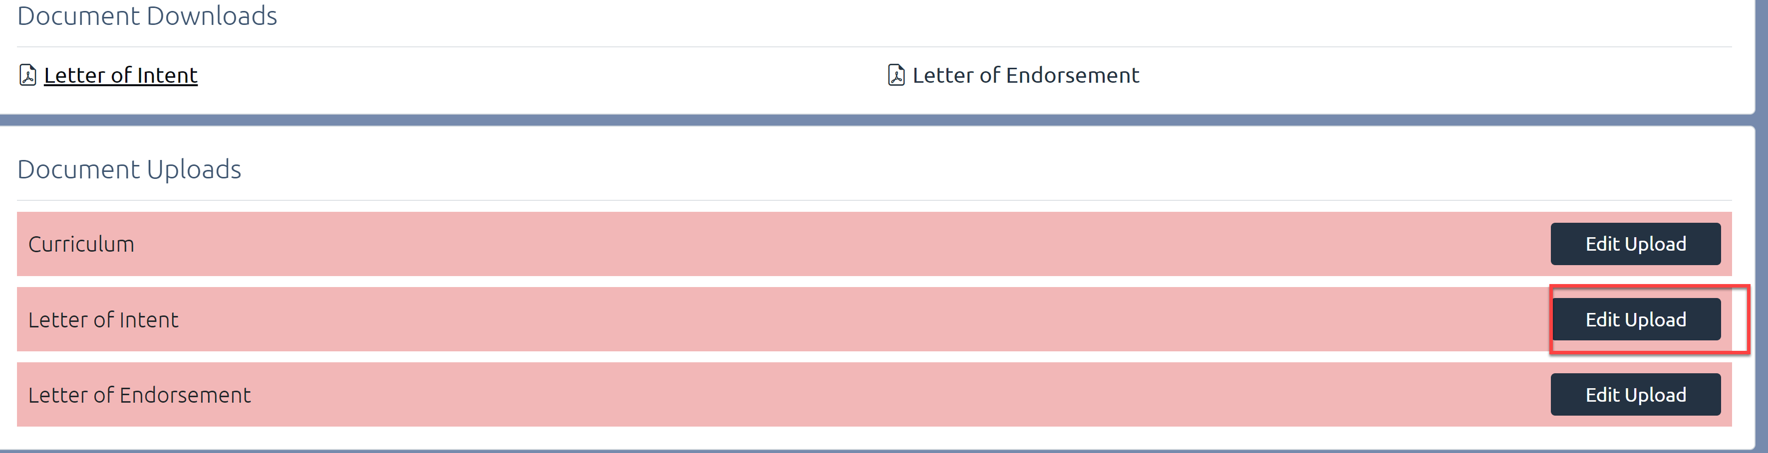

Get in contact with your National CEEPUS Office for further help.

