HOW TO REGISTER FOR A MOBILITY Application
HOW TO REGISTER FOR A NETWORK Application
For all CEEPUS applications: You have to register and create an account under My CEEPUS first.
All registered persons automatically obtain the desktop “mobility” and therewith can apply for mobilities.
If you also want to create a new network, take part as contact person for your institutions in an existing CEEPUS network, you need to additionally be registered for managing a CEEPUS network.
You will then obtain the desktop “network” and have access to your participating units and the respective mobility applications, or can apply as contact person for your institution.

- How to register in the CEEPUS software.
First click on MY CEEPUS on the CEEPUS website www.ceepus.info

Click on “Click here to register”
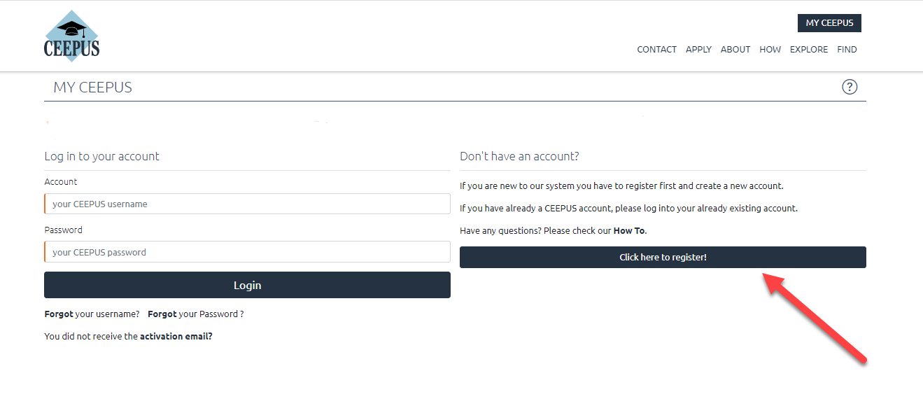
In the next step please fill in the required data and click on submit
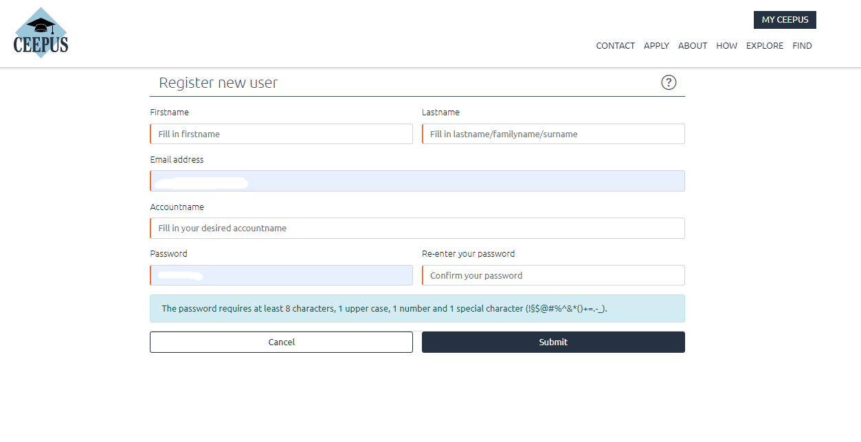

Now please check your emails, also check the spam folder. Then activate your CEEPUS account.
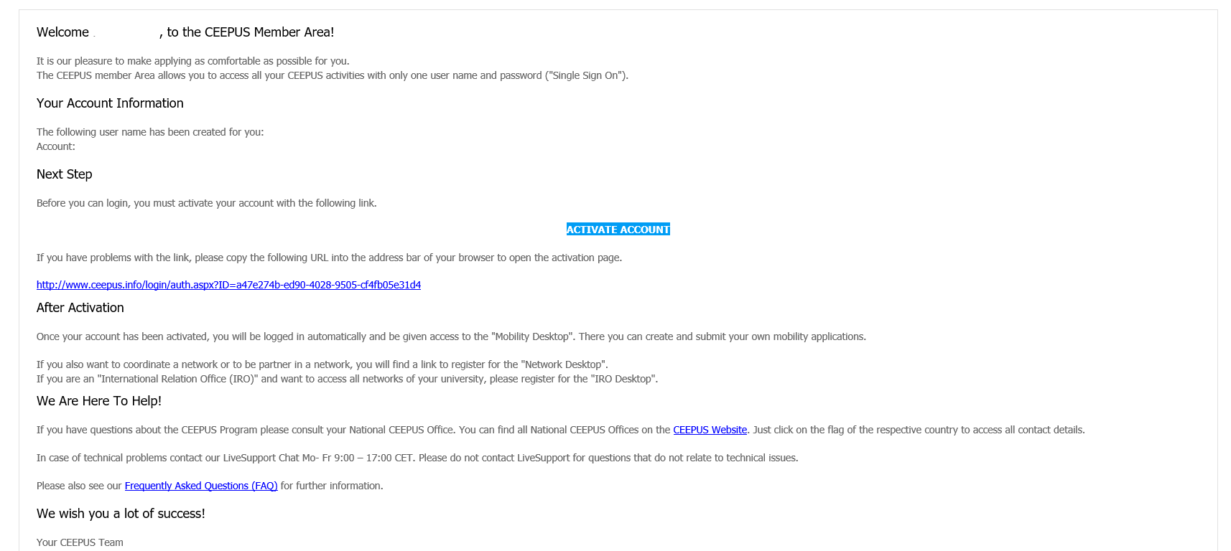

Now you have access to your CEEPUS Mobility Desktop, and you can apply/create new mobility applications.
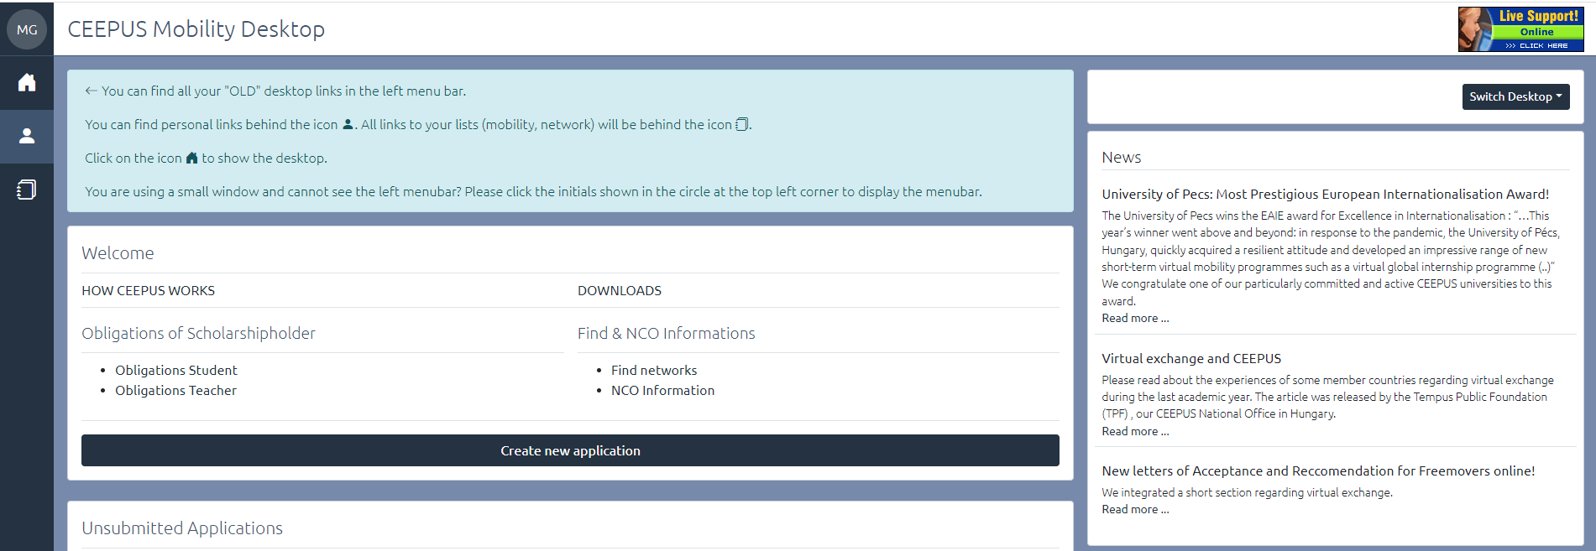

- How to register for managing a CEEPUS network, for network applications
You must apply for a network desktop:
- If you want to take part in an existing CEEPUS network as contact person for your institution
- if you want to create a new CEEPUS network, as coordinator of the network
Sign into “My CEEPUS”
Click on “Register for managing a CEEPUS network” under your personal settings
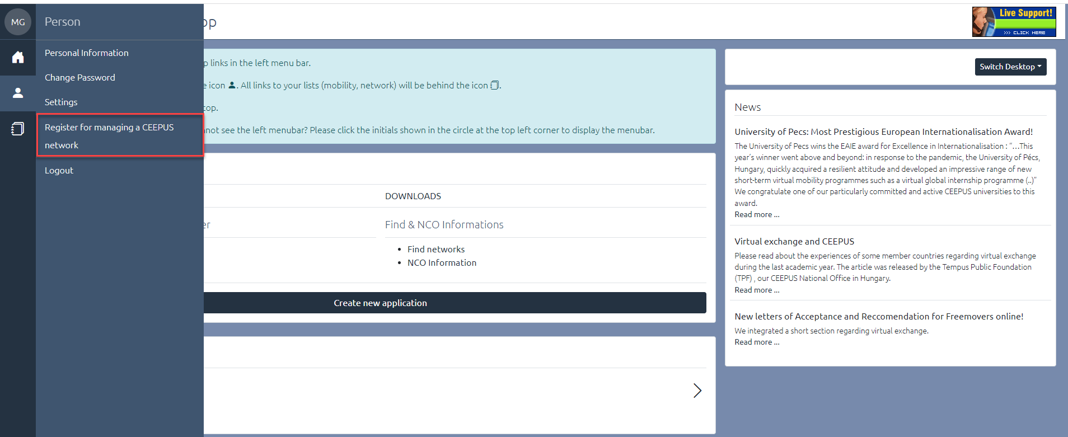

Please click on “Register for “Network Desktop”:
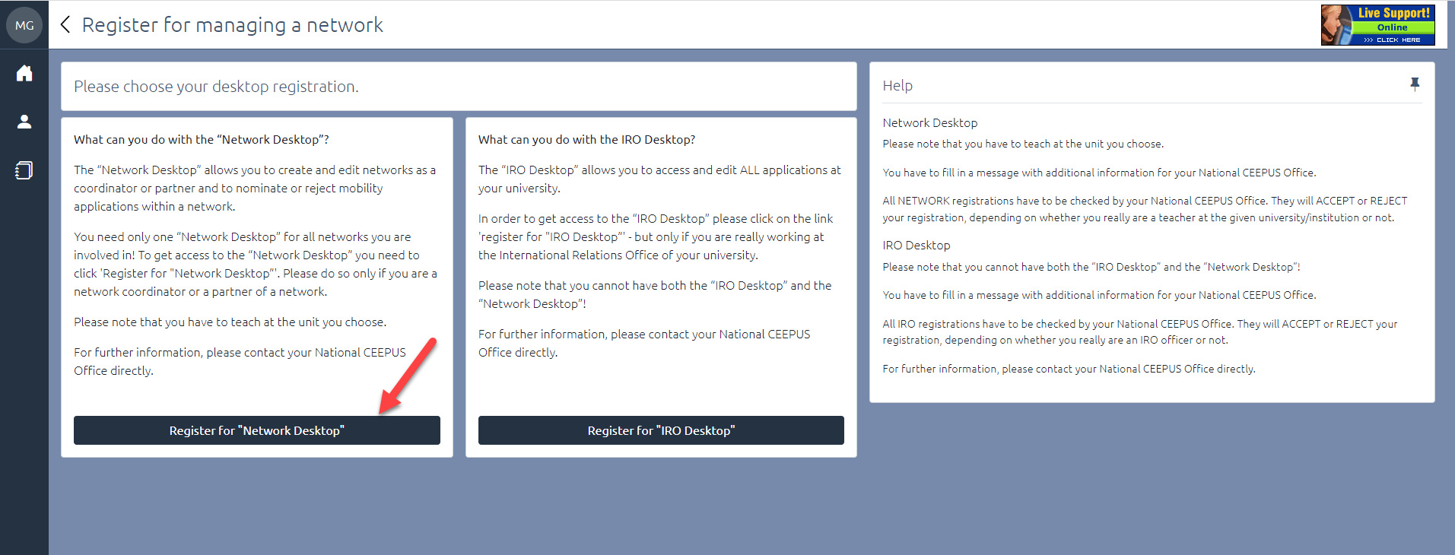

In this section, please fill in all requested information about your institution you belong to. Confirm that you are teacher, and you want to be part of a network or create a network.
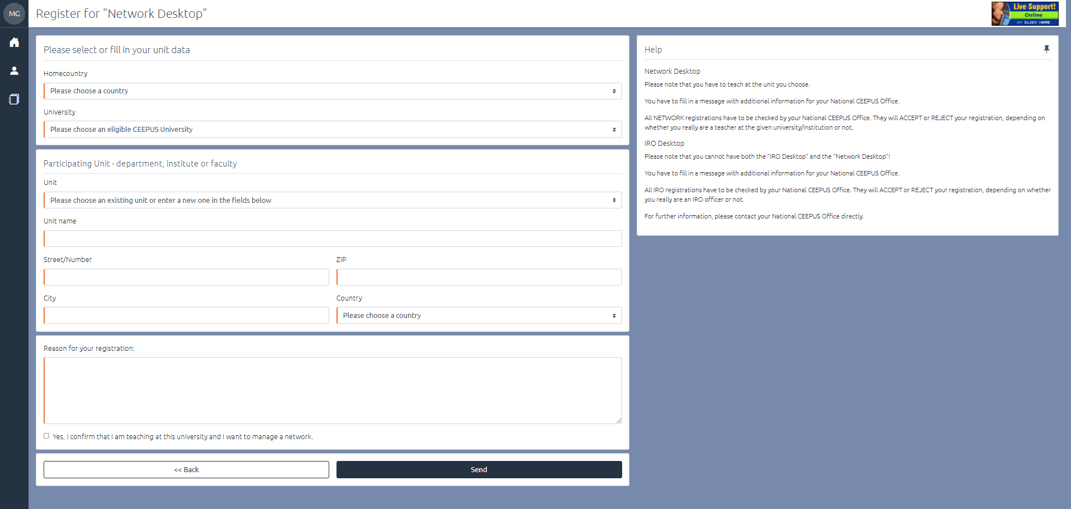

After clicking on the send button, the respective National CEEPUS Office has to accept your request and the coordinator can add you to an already existing network or you can create a network.
If you have further questions please contact your National CEEPUS Office in your country or contact the Central CEEPUS Office.

