Analysis of existing research infrastructures in the Republic of North Macedonia

(Annex 1)

2022-2024

Ministry of Education and Science

In September 2024, a survey questionnaire was sent to all relevant research institutions in the Republic of North Macedonia by the Ministry of Education and Science in order to gather information on research infrastructures. The questionnaires were filled out by research laboratories and institutes operating within public and private universities, public and private scientific institutions. The response rate was extremely high, considering that the majority of research institutions responded to the request. As anticipated, the largest number of responses came from the University of "Ss. Cyril and Methodius" - Skopje as the nation's most significant university.

4.1 Overview of research infrastructures
Overview of all 44 projects (3 projects are not implemented) awarded based on the Competition for funding scientific and research projects of special and public interest for 2021 (support for laboratory resources development) that were funded in the period 2021, 2022 and 2023 by project lines:
- Faculty of Technical Sciences, Bitola, University "St. Kliment Ohridski"- Bitola
Project: Accreditation of the Laboratory for the protection of the living and working environment/Line 1/In the field of Technical and Technological Sciences
Project leader: Prof. Dr. Vladimir Mijakovski
Email: кostov@uklo.edu.mk
Purchase price: 490,219.00 denar (100% contribution of the Ministry of Education and Science).
Laboratory description: The project secured funding for the accreditation of the Laboratory for protection of environment and working environment. The Laboratory, along with its measuring equipment and the established measurement procedures, serves as a crucial foundation for identifying and addressing environmental issues from both practical and scientific perspective, thus ensuring originality in the research and advancement of this field. The Laboratory will greatly enhance the scientific research activity taking place at the Faculty of Technology - Bitola, particularly in the implementation of research projects focused on protection of environment and working environment. Considering that our institution offers accredited study programmes in Engineering for protection of environment and working environment for the first and second cycles of studies, as well as study programmes in Mechanical Engineering (in the area of Technical and Technological Sciences, field and area of ​​studies Mechanical Engineering, Energy, and Environment) for the third cycle of studies, the accredited Laboratory will support our ongoing efforts to create up-to-date, innovative, and high-quality curricula, and will particularly assist students and junior researchers by fostering a scientific-research mindset while mastering the curriculum and addressing assigned tasks in the most advanced manner.

- Faculty of Biotechnical Sciences - Bitola, University "St. Kliment Ohridski" - Bitola
Project: Competence of the Laboratory for extraction of essential oils from spice and medicinal plants and determination of biologically active substances based on application of МКС EN ISO/IEC 17025:2018/Line 1/In the field of Biotechnical Sciences
Project leader: Assoc. Prof. Dr. Elena Joshevska
Email: info.fbn@uklo.edu.mk
Purchase price: 457,238.00 (100% contribution of the Ministry of Education and Science)
Laboratory description: The Laboratory for extraction of essential oils from spices and medicinal plants and determination of biologically active substances, which is 50 m² in size, is used for conducting modern scientific research and is equipped with: gas chromatography with a flame ionization detector (FID) and mass detector (MSD): ultra-high performance liquid chromatography with diode array detector; high-performance liquid chromatography (HPLC) with diode detector and post-column derivatisation; atomic absorption spectrometer AAC-7000; UV-VIS spectrophotometer with diode detector; essential oil distillation apparatus; Kjeldahl digestion unit; analytical balance and hygrometer; other laboratory equipment, technical instruments and glassware.
The policy for access to the research infrastructure of the Laboratory for extraction of essential oils from spices and medicinal plants and determination of biologically active substances covers the end users who already use the services of the Laboratory and include: students of all three study cycles, teaching and research personnel and associates of the faculty, business entities with which the faculty has signed cooperation agreements, public institutions involved in the research areas to conduct tests, training, and inter-laboratory research.
- Faculty of Technology and Technical Science - Veles, an affiliated institution of the University “St. Kliment Ohridski” - Bitola
Project: Accreditation of the Laboratory of the Food Technology Centre for Development of Innovative Products (FTC) at the Faculty of Technology and Technical Science, UKLO/Line 1/In the field of Technical and Technological Sciences
Project leader: Assoc. Prof. Dr. Daniela Nikolovska Nedelkoska
E-mail: daniela.nedelkoska@uklo.edu.mk
Purchase price: 402,692.00 denar (100% contribution of the Ministry of Education and Science)
Laboratory description: The Laboratory is equipped for the analysis of raw milk: determination of protein content (ISO 8968-1:2014), total colony count (MKC EN ISO 4833-2:2013), somatic cells (MKC EN ISO 13366-2:2010) and aflatoxin M (according to the manufacturer's instructions for the VICAM 4EX instrument). The Laboratory also has equipment for microbiological analysis of various food and water samples, automated equipment for protein determination by Kjeldahl, automated equipment for fat determination by Soxlet, an instrument for water activity (aw) measurement, a spectrophotometer and other laboratory equipment necessary for conducting analyses related to food quality and safety. The laboratories of the Food Technology Centre for Development of Innovative Products (FTC) have implemented a quality management system in accordance with the international standard MKC EN ISO 17025:2018.
The goal was to provide the food industry companies with access to a laboratory and an innovation centre where they could develop innovative ideas, receive expert assistance, and research and test new products, while the Faculty's expert personnel is engaged in four applicative projects for the needs of the food industry.

- Faculty of Computer Science and Engineering (FINKI), University "Ss. Cyril and Methodius" - Skopje
Project: Open Science Cloud Research Laboratory/Project line 3/In the field of Technical and Technological Sciences
Laboratory name: Open Science Cloud Research Laboratory
Project leader: Prof. Dr. Boro Jakimovski
Email: boro.jakimovski@finki.ukim.mk
Principal researcher: Prof. Dr. Anastas Mishev
Email: anastas.mishev@finki.ukim.mk
Purchase price: 30,000,000.00 denar (70% or 21,000,000.00 Ministry of Education and Science; 30% or 9,000,000.00 denar own funds)
Laboratory description: The Open Cloud Research Lab is the largest open research e-Infrastructure in the country. The Open Science Lab consists of two main systems, each with a specific purpose. The first system is an open cloud intended for national researchers, which allows them to deploy their own virtual infrastructure for high-performance computing. The system's entire operation is predicated on the self-service approach, in which users autonomously manage their own resources, from setting up virtual machines, through network configuration, to adding additional storage space. With 640 processor cores overall and more than 15 TB of working memory, the state-of-the-art computer hardware that this system is installed on ensures excellent performance.
The second system is designed to perform complex computational tasks, with the additional option of using graphics processors. Researchers can independently schedule the execution of a complex task, choosing whether they need dedicated graphics processors. The system is equipped with state-of-the-art hardware, including a total of 8 graphics processors with a total video memory of 640 GB, making it suitable for application in researching problems from a variety of fields, where the use of graphics processors would speed up calculations.
In order to enable smooth operation with big data, both systems have a fast connection to a centralized storage space that offers over 2 PB of total space available. This space can be used in a number of ways, depending on the needs of the researchers, including: running virtual machines, long-term storage of data sets, storage of input and output data during their analysis, and general access through a programming interface (API) for integration with third-party computing systems.
The laboratory was procured with the support of the Ministry of Education and Science, through the Competition for funding scientific research projects of special and public interest for 2021 (support for development of laboratory resources) (70%), and co-funding by FINKI - UKIM (30%).
The laboratory consists of several components: GPGPU cluster, Openstack cloud and Data storage.
All researchers in the country, regardless of the scientific discipline of study, are eligible to use this laboratory. In order to facilitate their access to this infrastructure, regular trainings and workshops are planned, which will be aimed both at the use of the infrastructure and current scientific trends pertaining to open science and FAIR (Findable, Accessible, Interoperable, and Reusable) data. These training sessions will be organized in cooperation with the ongoing EOSC H2020/HE-related projects, in which FINKI - UKIM is currently actively involved.
Access to 70% of all resources of the Open Cloud Research Lab will be made available to all researchers in the country, based on open calls. The open calls will be evaluated periodically on a bimonthly basis, both from a technical and scientific perspective, and project proposals that have applied for resources and meet the technical and scientific criteria will be allowed to use the laboratory resources.
https://finki.ukim.mk/sites/default/files/u703/finki_open_access_policy_1.0.pdf
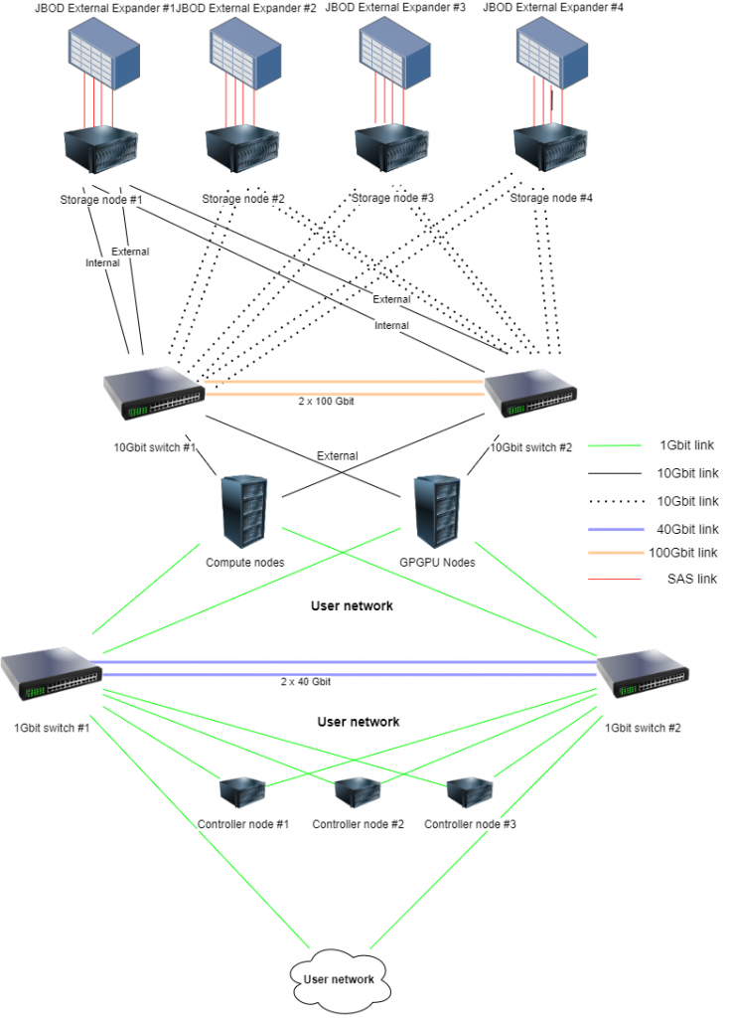

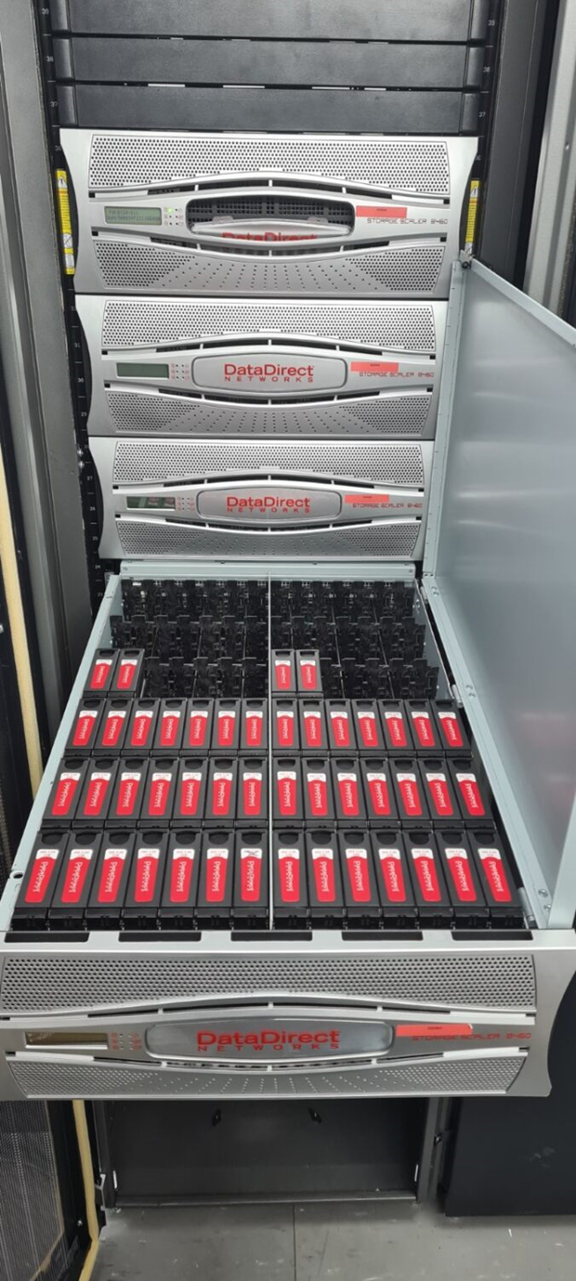

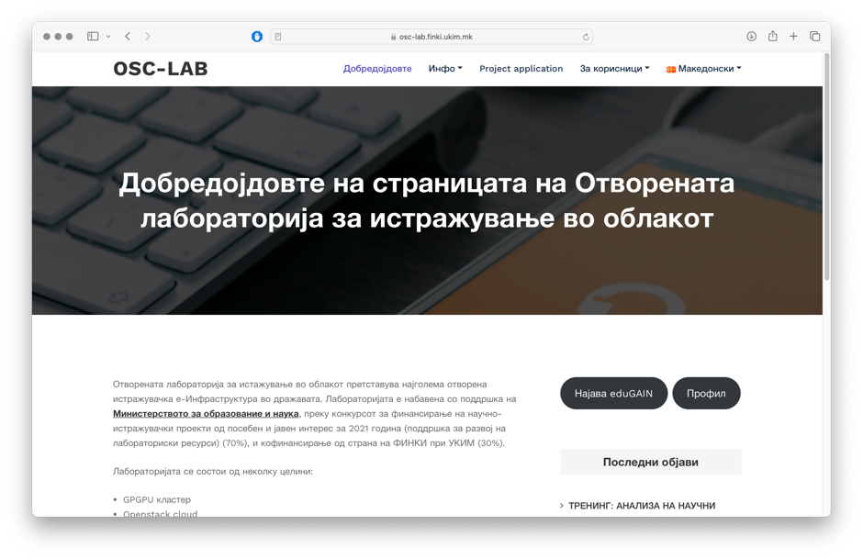

- Institute of Earthquake Engineering and Engineering Seismology (IZIIS) - Skopje, University "Ss. Cyril and Methodius" - Skopje
Project: Integrated Mobile Laboratory for Field Research and Assessment of Damage from Earthquakes and Other Events (EQ-MOBI-LAB)/Line 3/In the field of Technical and Technological Sciences
Project leader: Associate Professor Zoran Rakichevikj
Email: zoran.r@iziis.ukim.edu.mk
Purchase price: 21,771,800.00 denar (15,240,260.00 contribution of the Ministry of Education and Science and 6,531,540.00 own funds)
Laboratory description: The primary activities of the Integrated Mobile Laboratory (EQ-MOBI-LAB) for Field Research and Assessment of Damage from Earthquakes and Other Events include: comprehensive field research, non-destructive monitoring and diagnosis of regular and special structures; urgent diagnostics in emergency and other post-disaster situations caused by natural, technical-technological and other hazards and/or threats; urgent, near real-time non-destructive testing (NDT): monitoring, diagnosing, assessing conditions, and defining emergency protection measures for structures, infrastructure, critical systems, soil constructions, and other systems exposed to natural disasters (earthquakes, landslides, terrain collapses, floods, and others), technical accidents and disasters (explosions, fires, consequences of poor construction quality or inadequate operational regimes, material fatigue, aging structures, infrastructure, and others), warfare (as a result of airstrikes, artillery attacks, unexploded ordnance explosions, and others), threats (terrorism, sabotage, etc.); regular monitoring and diagnostics of structures, critical, and other infrastructure systems for their maintenance, upgrading/expansion, re/activation, capacity enhancement, and more; quality and defectology of construction materials; environmental protection; qualitative and quantitative analysis of phenomena related to the static and dynamic behaviour of soil masses, deposits, structures (embankments, cuttings, excavations, fill dams, etc.), and their transformation into hazards for populations and created assets; transfer and development of methodologies, techniques, technologies, and procedures for NDT monitoring, diagnostics of structures, vital infrastructure, and critical systems; qualitative and quantitative analysis, and defectology of soil structures and natural systems.

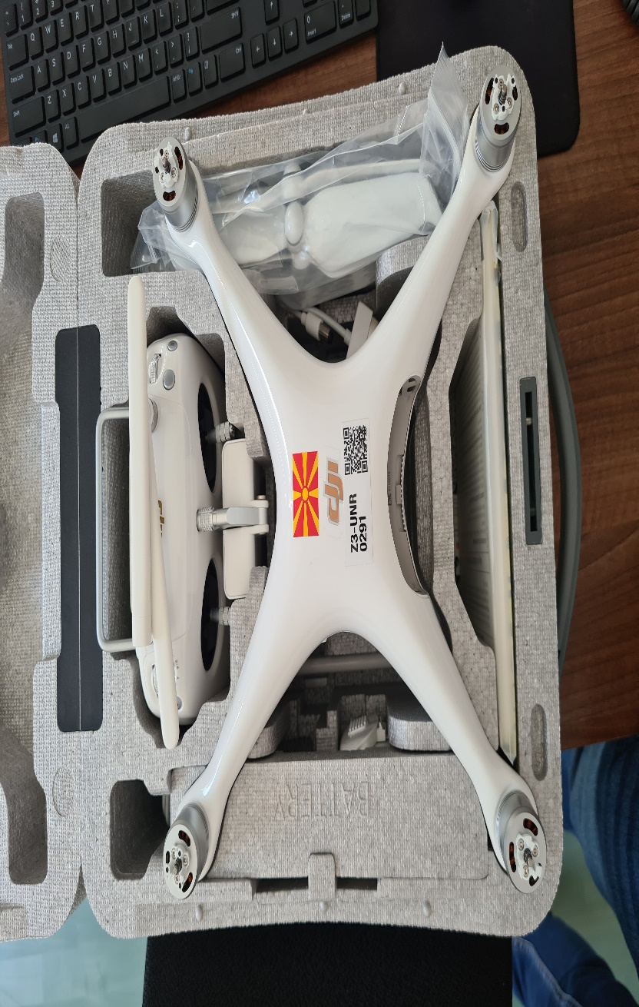

- Faculty of Civil Engineering, University of Ss. Cyril and Methodius - Skopje
Project: Study of the soil-structure interaction using innovative systems for testing pile structures as part of engineering facilities /Line 3/In the field of Technical and Technological Sciences
Project leader: Prof. Dr. Josif Josifovski
Email: jjosifovski@gf.ukim.edu.mk
Purchase price: 3,103,680.00 denar (1,798,851.00 contribution of the Ministry of Education and Science; 1,304,829.00 own funds and other sources)
Laboratory description: Digitalization using a triaxial test apparatus; Digitalization using a direct shear test apparatus; Digitalization using an oedometer apparatus; Procurement of computers and software development; Dynamic loading system (platform); Digitalization of the measurement system for static pile testing; Total station for geodetic survey and monitoring of tests; Tapping machine; Determination of the strength parameters of medium and coarse-grained soils (cohesion and angle of internal friction); Determination of the deformable properties of the soil for different loading levels expressed through the compressibility modulus; Registration, processing and calculation of the required measured values; Determination of the bearing capacity of piles under the action of dynamic loads; Determination of the bearing capacity of piles under the action of static loads; Measurement and control of the design geometric parameters during dynamic loading of piles; Generation of impact sound, measurement of sound insulation of inter-storey structures.
All internal clients, members and students of the Faculty of Civil Engineering have unlimited access to the research infrastructure. Their work must be mentored and supported by the technical personnel. The costs of the infrastructure use must be covered by internal or external sources (donations, public funds, international funds, etc.).
All external clients must apply for access to the research and laboratory infrastructure of the Faculty of Civil Engineering. The Faculty's Scientific Committee decides individually on each application, which includes a financial component and a proposed advisor.

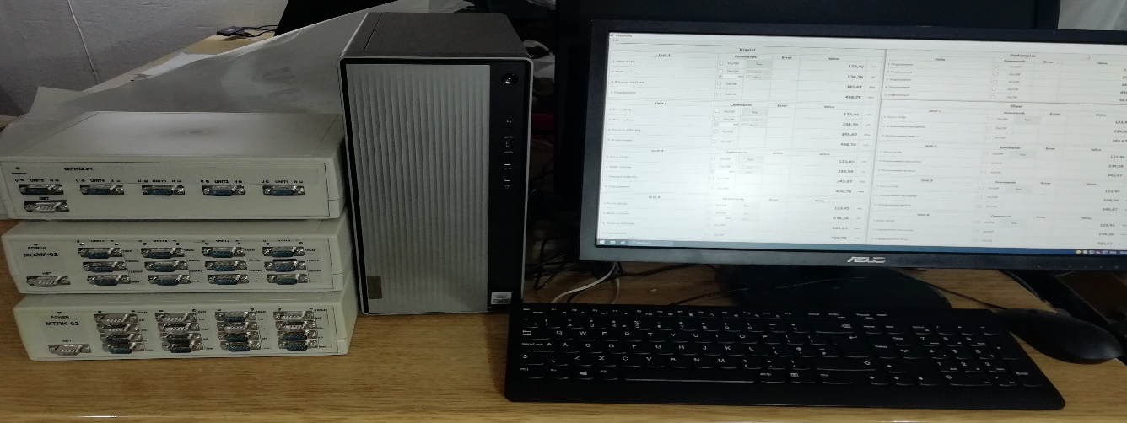
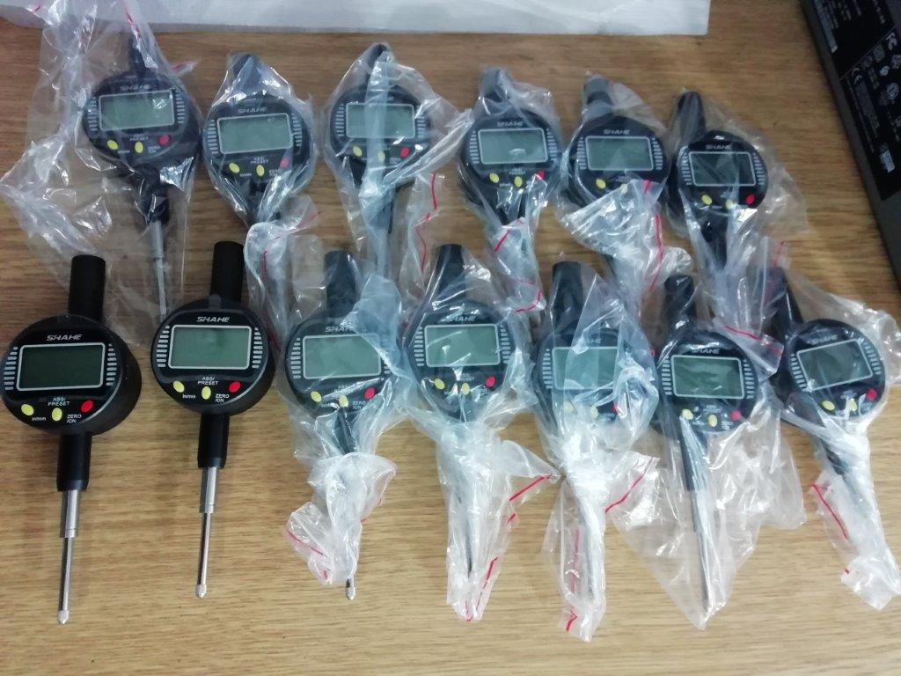

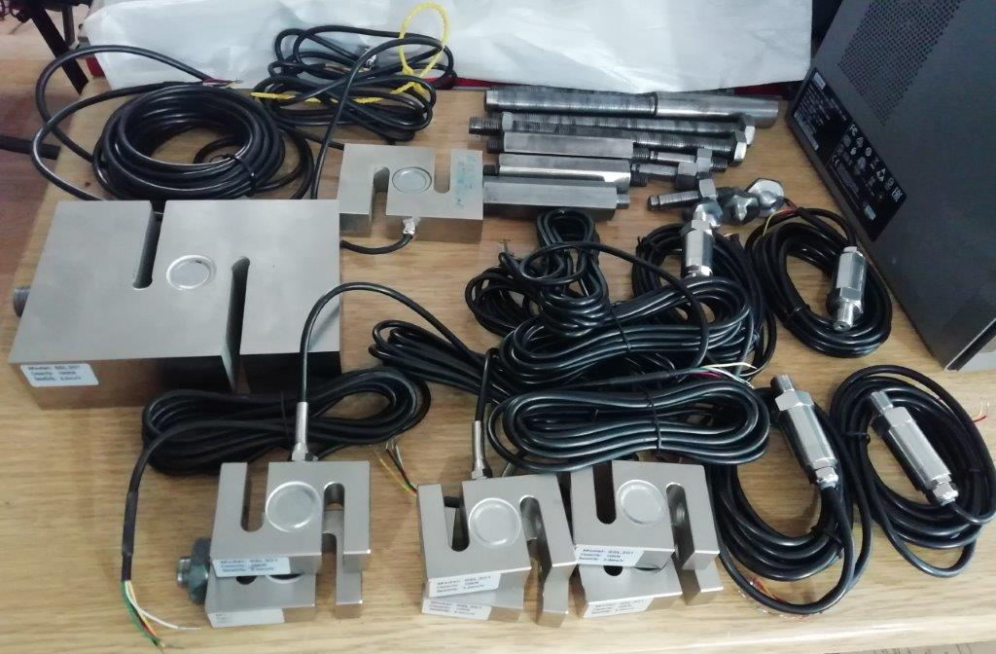

- Faculty of Civil Engineering, University "Ss. Cyril and Methodius" - Skopje
Project: Numerical modelling and experimental testing of thermal and acoustic properties of building materials and elements, as well as their optimization to increase building comfort, Acronym: AKUTERMOLAB /Line 2/In the field of Technical and Technological Science
Project leader: Prof. Dr. Todorka Samardzioska
Email: samardzioska@gf.ukim.edu.mk
Purchase price: 2,234,442.00 denar (100% contribution Ministry of Education and Science)
Laboratory description: Software including acoustics, heat and structural mechanics modules; Measurement of thermal conductivity of several types of building materials; Portable omnidirectional sound source for acoustic measurements; Generation of impact sound, measurement of sound insulation of inter-storey structures.
Access policies: All internal clients, members and students of the Faculty of Civil Engineering have unlimited access to the research infrastructure. Their work must be mentored and supported by the technical personnel. The costs of the infrastructure use must be covered by internal or external sources (donations, public funds, international funds, etc.).
All external clients must apply for access to the research and laboratory infrastructure of the Faculty of Civil Engineering. The Faculty's Scientific Committee decides individually on each application, which includes a financial component and a proposed advisor.

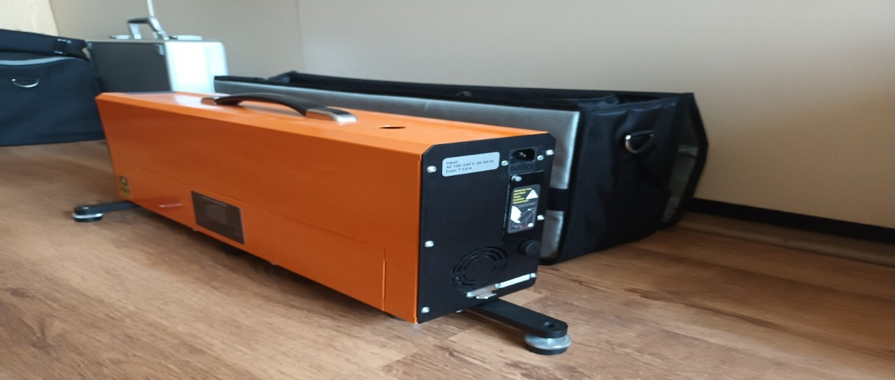

- Faculty of Technology and Metallurgy, University "Ss. Cyril and Methodius" - Skopje
Project: Application of modern separation techniques for isolation of bioactive components from tomato peels (selanum lycopercicum)/Line 3/In the field of Technical and Technological Sciences
Project leader: Prof. Dr. Kiril Lisichkov, Prof. Dr. Stefan Kuvendziski
Email: mirko@tmf.ukim.edu.mk
Purchase price: 7,889,780.00 denar (4,780,880.00 denar contribution of the Ministry of Education and Science, 3,108,900.00 denar own funds).
Laboratory description: Purchase of a UV spectrophotometer, analysis sets and raw materials for UV/Vis analyses. The purchased UV spectrophotometer is used for the isolation of bioactive components of tomato peels. The purpose of the research is to produce tomato peel extracts that can be used in cosmetics and pharmaceuticals. Previously, the research activities were conducted in laboratories in the Republic of Serbia, which required funds for travel and accommodation costs. The purchase of the spectrophotometer will allow research on the extraction of functional extracts from tomato peels, onion peels, leek peels, etc. Analysis sets and raw materials for UV/Vis analyses were also purchased in addition to the spectrophotometer. This research infrastructure - Laboratory for Separation Processes is intended for the design of contemporary separation processes for the extraction of components of interest from raw materials of natural origin for use in the food, pharmaceutical, cosmetic and other industries.
Access policy: Access for researchers from the Faculty is free - they bring their samples for analysis.
Access for external persons: They email the faculty a request form and bring samples for testing; the administrative office creates and sends an invoice form; the measurement and testing report is prepared; the dean signs it; and the testing report is distributed to the clients.
- Faculty of Veterinary Medicine - Skopje, University "Ss. Cyril and Methodius" - Skopje
Project: Development and validation of multi-residue and multi-class analytical methods for the determination of residues of veterinary drugs contaminants in food of animal origin using isotopically labelled internal standards and application of the LC-Q/TOF technique/Line 3 /In the field of Biotechnical Sciences
Project leader: Prof. Dr. Zehra Hajrulai-Musliu
E-mail: zhajrulai@fvm.ukim.edu.mk
Purchase price: 20,529,132.00 denar (14,370,392.00 contribution of the Ministry of Education and Science, 6,158,740.00 own funds).
Laboratory description: The Food Quality Control Laboratory is an accredited laboratory according to the ISO 17025 standard and is authorized to perform analyses and superanalyses of food and animal feed. It has modern measuring and testing equipment, as well as infrastructure for the correct and safe performance of tests. The laboratory performs quality control of food of animal and plant origin, quality control of animal feed, quality control of wine and honey, as well as quality control of drinking water and water used in industrial production. The Laboratory also performs analysis of residues and contaminants and is an authorized laboratory for the implementation of the National Monitoring Programme of the Republic of Macedonia for residues and contaminants in products of animal origin, in accordance with the EU Council Directive 96/23/EEC.
In terms of users, cooperation with external users (economic operators, laboratories, traders, and clients) is one of the primary objectives of this research infrastructure, and upon their request, the number and scope of food analysis methods are increased.
Access policies: The time and activities related to the access and use of the equipment are agreed upon in advance with the laboratory's head. Because the laboratory is accredited, access is granted in accordance with Procedure P8.06.01: Procedure for User Relations. A unique access mechanism has not been implemented, and access is based on a signed collaboration agreement with partner institutions.
.
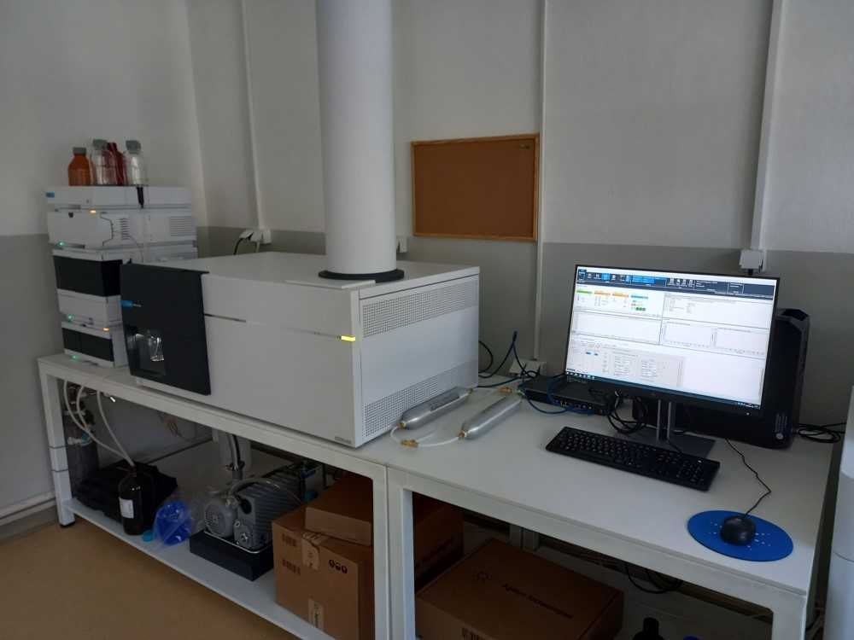

- Faculty of Veterinary Medicine - Skopje, University "Ss. Cyril and Methodius" - Skopje
Project: Preparation and equipping of a Laboratory for Animal Hygiene and Environmental Protection /Line 3/In the field of Biotechnical Sciences
Project leader: Prof. Dr. Miroslav Kjosevski
Email: miro@fvm.ukim.edu.mk
Purchase price: 3,495,752.00 denar (2,190,752.00 contribution of the Ministry of Education and Science, 1,305,000.00 own funds).
Laboratory description: The Laboratory for Animal Hygiene and Environmental Protection applies accredited methods for measuring the quality parameters of air, water, soil, surfaces, performing microclimate measurements, as well as determining the environmental effects of farms and facilities that house domestic animals.
The results are used by Macedonian farms and institutes with a primary animal-related activity. Internal users are master's and doctorate students, while external users include state agencies like the Food and Veterinary Agency, the Ministry of Environment and Spatial Planning etc.

- Faculty of Pharmacy, University “Ss. Cyril and Methodius” - Skopje
Project: Introduction of new wet granulation methods in research and development of modern dosage forms/Line 2 /In the field of Medical Sciences and Health
Project leader: Prof. Dr. Marija Glavash Dodov, full professor, Prof. Dr. Nikola Geshkovski, associate professor
E-mail: magl@ff.ukim.edu.mk
Purchase price: 3,096,000 denar (2,930,000.00 denar contribution of the Ministry of Education and Science, 166,000.00 denar own funds).

Laboratory description: A fluid bed granulator was purchased with the capacity to perform the following operations: spraying a liquid from the top of the system down (top spray) and bottom spray, Wuster mode in a specifically designed chamber that is applied in coating. regenerative medicine, as well for examining the pharmaco-toxicological profiles of various medicines. The provision of this important laboratory resource (fluid bed granulator) has opened a new area of ​​research at IFT that is up to date from a professional and scientific perspective. The application of quality by design (QbD) elements, such as experimental design, multivariate analysis and process analytical technologies, as IFT researchers' previous experience in formulation preparation and wet granulation process optimization using the specified equipment, will significantly contribute to the deepening and expansion of scientific knowledge in this area. Wet granulation is one of the most important processes used for the preparation of conventional solid dosage forms, but also of modern forms as in the case of coating of granules, pellets, tablet cores, etc.
The laboratory's services are used by the pharmaceutical companies Alkaloid AD Skopje, Replek and the other organizational units of the University.
The access to the research infrastructure is regulated and granted to the personnel of the Faculty of Pharmacy and the students of the same institution who are trained to operate the research infrastructure; external project participants/researchers who are trained to operate the specific equipment included in the project application or based on an agreement/memorandum of cooperation with the laboratory.
In addition, a number of undergraduate theses were prepared in these areas.
- Faculty of Pharmacy, University “Ss. Cyril and Methodius” - Skopje
Project: Stability analyses of cannabis and its products and preparations/Line 2/In the field of Medical Sciences and Health
Project leader: Prof. Dr. Marija Karapandzova
Email: ivanacvetkovikj@ff.ukim.mk
Purchase price: 3,000,000 denar (2,999,500.00 contribution of the Ministry of Education and Science, 539,910 own funds)
Laboratory description: Introduction of analytical methods, establishment of a quality system, and accreditation that addresses the testing and control of different cannabis varieties and their extractive products as herbal raw materials for medical applications. Liquid chromatography (HPLC) is the analytical platform utilized for phytochemical analysis of natural phytocannabinoids, and it is the foundation of the pharmacopeial method. Furthermore, the stability of cannabis is determined, which entails developing methods that include placing a large number of samples in a stability chamber under specific conditions and analysing the cannabinoid concentration over a 3 to 36-month period.
Users are private companies from the cannabis industry; Alkaloid AD Skopje; Replek; State Phytosanitary Laboratory.

- Faculty of Pharmacy, University “Ss. Cyril and Methodius” - Skopje
Project: Strengthening laboratory capacities for detecting counterfeit medicines as part of the Strategy of the Republic of Macedonia for countering counterfeit medicines/Line 2/In the field of Medical Sciences and Health
Project leader: Prof. Dr. Katerina Brezovska, associate professor
E-mail: liug@ff.ukim.edu.mk
Purchase price: 3,539,410.00 denar (2,999,500.00 denar contribution of the Ministry of Education and Science, 539,910.00 denar own funds)
Laboratory description: Laboratory (pharmaceutical-chemical and technological) testing of: - substances (active substances, excipients) and finished products. -regular quality control of all medicines placed on the market in the Republic of Macedonia, performed at least once every five years; quality control of the first batch of medicines/parallel imported medicines, performed before placing the medicine on the market; quality control of each batch of medicines/parallel imported medicines; extraordinary quality control, i.e. quality control of a medicine performed upon request of the Agency either during the procedure for obtaining a marketing authorization or after the issuance of the authorization; laboratory testing before starting a clinical study. The quality control of medicines, in accordance with Article 100 of the Law on Medicines and Medical Devices, refers to: regular quality control of all medicines placed on the market in the Republic of Macedonia, performed at least once every five years; quality control of the first batch of medicines/parallel imported medicines, performed before placing the medicine on the market; quality control of each batch of medicines/parallel imported medicine; extraordinary quality control, i.e. quality control of a medicine performed upon request of the Agency either during the procedure for obtaining a marketing authorisation or after the issuance of the authorisation; laboratory testing before starting a clinical study.
User of this Lab is the University of Ss. Cyril and Methodius - Skopje.

- Faculty of Pharmacy, University “Ss. Cyril and Methodius” – Skopje
Project: Introduction of a new method for dPCR somatic mutations detection from liquid biopsy/Line 3/In the field of Medical Sciences and Health
Project leader: Prof. Dr. Nadica Matevska-Geshovska
Email: nmatevska@ff.ukim.edu.mk
Purchase price: 9,322,000.00 denar (6,059,300.00 denar contribution of the Ministry of Education and Science, 3,262,700.00 denar own funds)
Laboratory description: The Centre for Biomolecular Pharmaceutical Analysis is a 250 m2 facility that is divided into five rooms - four laboratories and a reception area. The laboratories are designed in accordance with the standards for molecular diagnostic activities and include: a sample preparation laboratory (pre-PCR room), an analysis preparation laboratory (master-mix room), a PCR product analysis laboratory (post-PCR room) and a cell culture analysis laboratory. The laboratories are equipped with the most modern equipment needed to perform analyses in the field of molecular diagnostics.
The access to the research infrastructure is regulated and granted to the personnel of the Faculty of Pharmacy and the students of the same institution who are trained to operate the research infrastructure; external project participants/researchers who are trained to operate the specific equipment included in the project application or based on an agreement/memorandum of cooperation with the laboratory.

- Faculty of Pharmacy, University “Ss. Cyril and Methodius” – Skopje
Project: Improving the technical competence of the Centre for Pharmaceutical Nanotechnology by introducing standard analytical procedures in the field of rheometry and 3D bioprinting/Line 2/In the field of Medical Sciences and Health
Project leader: Prof. Dr. Maja Simonoska Crcarevska
Email: msimonoska@ff.ukim.edu.mk
Purchase price: 2,942,866.00 denar (2,861,820.00 denar contribution of the Ministry of Education and Science, 81,046.00 denar own funds)
Laboratory description: Expanding and strengthening understanding of 3D bioprinting and rheometry. 3D bioprinting is applied in pharmacy and medicine focusing on individual medicine formulations, as well as in the creation of complex tissue structures/organs that would be used in regenerative medicine.
Policies for access to research infrastructures primarily focus on training and education, as well as collaboration with other institutions and research teams to share best practices and information on granting access.
The access to the research infrastructure is regulated and granted to the personnel of the Faculty of Pharmacy and the students of the same institution who are trained to operate the research infrastructure; external project participants/researchers who are trained to operate the specific equipment included in the project application or based on an agreement/memorandum of cooperation with the laboratory.

- University "Goce Delchev" - Shtip, Faculty of Natural and Technical Sciences, Laboratory AMBICON
Project: Research Group for Advanced Aerosol Analysis/Line 3/In the field of Technical and Technological Sciences
Project leader: Prof. Dr. Blazho Boev
Principal investigator: Prof. Dr. Dejan Mirakovski
Email: dejan.mirakovski@ugd.edu.mk
Purchase price: 22,757,416.00 denar (15,932,292.00 denar contribution of the Ministry of Education and Science, 6,825,124.00 denar own funds)
Laboratory description: The AMBICON Laboratory has been functioning in different capacities for almost two decades within the Departments of Mining and Geology at the Faculty of Natural and Technical Sciences at the University "Goce Delchev" in Shtip.
The AMBICON Laboratory consists of two scientific groups in its current configuration: the ambient control and sampling group and the material analysis and testing group. Since 2014, the Laboratory has been accredited according to ISO 17025:2018 (Certificate LT-052 valid until 01.07. 2023) to control the qualitative and quantitative parameters of ambient air under conditions and in real time, to determine the degree of individual exposure to specific harmful substances, and to examine the morphology and chemical composition of different materials.
The laboratory has established long-term cooperation with numerous scientific institutions, industrial and service companies in the country and the region.
A dedicated Research Group for Advanced Aerosol Analysis has been established with the acquisition of cutting-edge equipment for the sampling of aerosols in ambient air and exhaust gases, as well as their detailed analysis using a new generation ultra-high resolution electron microscope. This has allowed for a significant expansion of the laboratory's capacity for scientific research and the range of accredited analytical services it offers.
The Laboratory's services are accessible to both external and internal users. Internal users include all employees of the University "Goce Delchev" in Shtip, along with students of the three cycles of studies at the University. External users include researchers from other state, private and international universities, research organizations, private companies, non-governmental organizations, government organizations, legal entities and individuals.
The AMBICON Laboratory, situated within the Faculty of Natural and Technical Sciences at the University "Goce Delchev" in Shtip, has established and enacted Open Access Policies that pertain to all research infrastructures of the Laboratory. These policies delineate the interactions between the Laboratory and the users of its open access services.

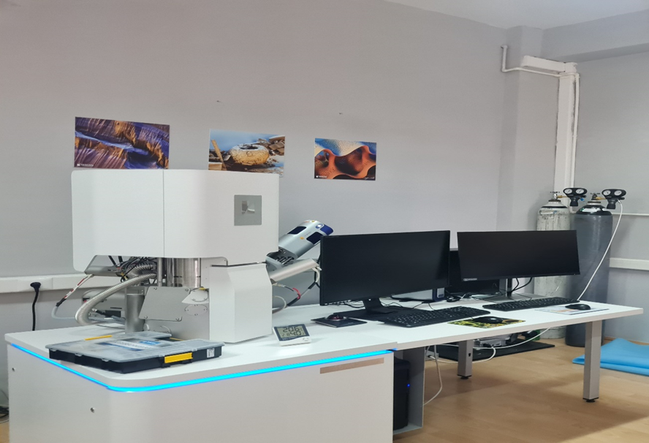

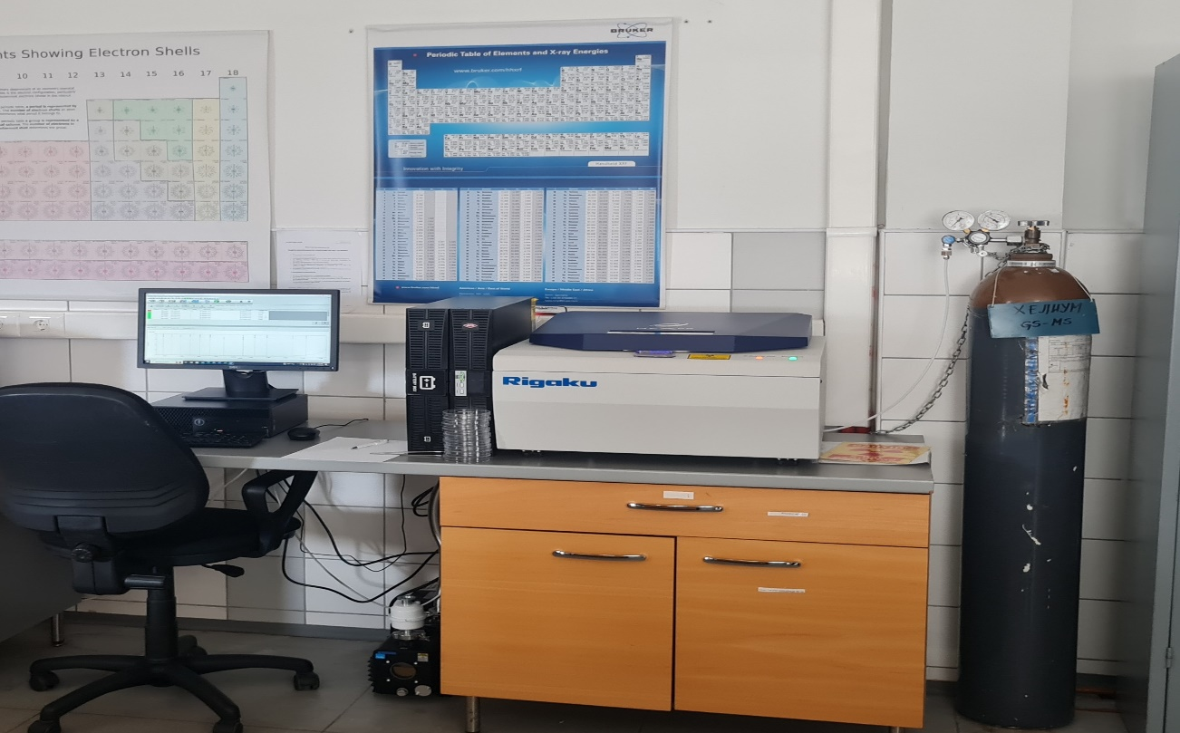

- Faculty of Electrical Engineering and Information Technologies (FEIT), University "Ss. Cyril and Methodius"- Skopje
Project: Development and upgradе of laboratory research resources and introduction of new analytical methods in electrical metrology/Line 2/In the field of Technical and Technological Sciences
Project leader: Prof. Dr. Marija Chundeva-Blaјer
Email: mcundeva@feit.ukim.edu.mk
Purchase price: 3,815,000.00 den. (2,767,947.00 denar contribution of the Ministry of Education and Science, 1,047,053.00 denar own funds)
Laboratory description: New methods were introduced in the Laboratory for Electrical Measurements related to calibration of measuring instruments for extreme direct and alternating currents, high frequency electrical signals, very high electrical resistances, very low electrical resistances and electrical inductance. A research infrastructure has been developed through the acquisition of reference standards for the calibration of instruments with a significantly expanded measuring range, including meters for new quantities, located in the laboratory premises of the Laboratory for Electrical Measurements at UKIM-FEIT.
In October 2023 the accreditation of LEM was extended until with validity until November 2027 with an expanded range of measuring and calibration capabilities published in the Annex to the Accreditation Certificate No. LK-012 issued by IARNM and available at www.iarm.gov.mk. The scope of LEM's accreditation covers calibration of instruments and generators for direct and alternating voltages and currents, resistance, capacitance, frequency, phase angle, electrical power and energy. LEM is the only national reference laboratory for electrical power and energy reference standards, particularly important for ensuring measurement traceability and uniformity of measurements in this very important area of legal metrology.
The LEM users include internal users and external researchers and the business sector.
The policy regarding access to the research infrastructure of the Laboratory for Electrical Measurements at UKIM-FEIT is publicly available at https://feit.ukim.edu.mk/wp-content/uploads/2020/11/pristapna-politika-lem.pdf

- Faculty of Electrical Engineering and Information Technologies, University "St. Cyril and Methodius"- Skopje
Project: Introduction of new analytical methods for electron spin resonance and thermoluminescence dosimetry/Line 2/In the field of Natural and Mathematical Sciences
Project leader: Prof. Dr. Margarita Ginovska
Email: hristina@feit.ukim.edu.mk
Purchase price: 7,779,240.00 denar (1,009,219.00 denar contribution of the Ministry of Education and Science, 6,770,021.00 denar own funds from IAEA)
Laboratory description: The Radiation Physics Laboratory (RAD-LAB) was established in 2018, as a continuation of the Centre for Solar Technologies and the accredited Laboratory for detection of irradiated food. RAD-LAB is accredited by the Institute for Accreditation of RNM and works according to the quality standard MKC EN ISO / IEC 17025:2018 for the following testing methods: detection of irradiated food, assessment of personal dose equivalent due to external exposure to ionizing radiation with thermoluminescence dosimeters for personal monitoring Hp (10); method for measurement of ambient dose equivalent H*(10) in the vicinity of sources of ionizing radiation in thе working place.
RAD-LAB is accredited entity by IARNM according to the МКС EN ISO/IEC 17025:2018 Standard for detection of irradiated food, assessment of personal dose equivalent, with Certificate of accreditation No. LT – 099.
The scope of work of RAD-LAB includes teaching activities in which students of the first, second and third cycle of studies work on practical assignments and research related to their undergraduate, master’s and doctoral theses. Internal users are FEIT students of all three cycles of studies, training participants at the FEIT Lifelong Learning Centre, as well as FEIT employees.
External users include students of all three cycles of studies at UKIM and other public and private universities in the country and abroad, scientists, researchers in government institutions and members of the civil society sector.
The Laboratory fosters a practice of openness and accessibility, and is committed to promoting collaboration in science, technology, and industry; consequently, a Policy for Access to the Laboratory's Research Infrastructure has been adopted.
- Faculty of Electrical Engineering and Information Technologies, University "St. Cyril and Methodius"- Skopje
Project: Laboratory for testing electromagnetic influences/Line 1/In the field of Technical and Technological Sciences
Project leader: Asst. Prof. Dr. Blagoja Markoski

- Faculty of Agricultural Sciences and Food, University "St. Cyril and Methodius" - Skopje
Project: Monitoring of harmful species of the Gelethidae and Totricidae families (Lepidoptera) on stone fruits in the Republic of Macedonia/ Line 2/In the field of Biotechnical Sciences
Project leader: Prof. Dr. Stanislava Lazarevska
E-mail: stanislava@fznh.ukim.edu.mk
Purchase price: 388,629.00 denar (100% contribution of the Ministry of Education and Science)
Project description: The Entomology Laboratory is a centralized facility of the Faculty of Agricultural Sciences and Food in Skopje. It was established with the establishment of the Faculty in 1947 for teaching purposes of the Department of Plant Protection, today organized as part of the Department of Entomology. The Laboratory is engaged in training of undergraduate, master's and doctoral students.
The laboratory is used to conduct study of insects and their classification into a particular systematic category.
In terms of access policies, the student laboratory is intended to provide student training.

- Faculty of Agricultural Sciences and Food, University "St. Cyril and Methodius" - Skopje
Project: Development and validation of an analytical method for the simultaneous determination of preservatives, sweeteners and caffeine in soft drinks/ Line 2/ In the field of Biotechnical Sciences
Project leader: Prof. Dr. Lenche Velkovska Markoska
E-mail: lencevm@fznh.ukim.edu.mk
Purchase price: 1,495,000.00 denar (100% contribution of the Ministry of Education and Science)
Laboratory description: Development of an analytical method for the simultaneous determination of sodium benzoate, potassium sorbate, aspartame, acesulfame K, saccharin and caffeine in various soft drinks and validation of the developed method for the simultaneous determination of the tested analytes in soft drinks.
Users include first, second and third cycle students of the faculty and other units of the University for educational purposes, students of vocational schools for project development, as well as professors for scientific and research purposes.

- Institute of Agriculture, University "St. Cyril and Methodius" - Skopje
Project: Correlation between macro and microelements in the soil-plant system/Line 2/In the field of Natural Sciences and Mathematics
Project leader: Prof. Dr. Julijana Cvetkovikj
Email: janacvetkovic@yahoo.com
Purchase price: 1,668,000.00 denar (1,548,000.00 denar contribution of the Ministry of Education and Science, 120,000.00 denar own funds)
Laboratory description: Within the framework of this project, a series of soil and plant material analyses were conducted, soil was cultivated with a focus on soils in enclosed spaces with controlled conditions. Plant material analyses were conducted concurrently with the soil analysis. The benefits of such activities are multiple: establishing a correlation between the content of micro and macro elements in the soil and plants at each stage of development; improving plant health and fruit quality; minimizing the excessive addition of macro and micro elements to the soil; monitoring the content of micro and macro elements at all stages of development and correcting any possible plant anomalies.
The end users of the results are greenhouses that produce plant-based food. In addition to the fact that healthy food will be produced in this way, regular soil quality control can lower production costs, which is a huge benefit for both producers and consumers.

- Institute of Animal Science at the University "St. Cyril and Methodius" - Skopje
Project: Implementation of ISO 17025 standard and accreditation of methods in the Laboratory for Milk and Dairy Products at UKIM Institute of Animal Science/Line 2/In the field of Biotechnical Sciences
Project leader: Prof. Dr. Natasha Mateva

- Faculty of Medicine, University "St. Cyril and Methodius" - Skopje, a total of 4 projects accepted for funding:
- Molecular Laboratory of Excellence for Gene Detection with the Latest Technology for Next-Generation Sequencing/Project line 3/In the Field of Medical Sciences and Health
Project leader: Prof. Dr. Gordana Petrushevska
Principal investigator: Aleksandar Eftimov, principal research fellow
Email: gordanap61@yahoo.com
Purchase price: 30,000,000.00 denar (21,000,000.00 denar contribution of the Ministry of Education and Science, 9,000,000.00 denar own funds)
Laboratory description: As a result of the project implementation, the molecular pathology laboratory was further equipped gaining features with excellence status. Three instruments featuring cutting-edge technology (latest generation) in the field of molecular pathology were acquired: a next-generation sequencing instrument that works on the principle of sequencing by synthesis, base by base for the detection of individual bases; a device for automated library preparation; an automated diagnostic DNA sequencer. This equipment is crucial for early disease diagnosis, which reduces the significant outflow of funds for medical services abroad; early disease and abnormality screening in prenatal diagnostics, which lowers foetal and neonatal mortality; and upgrading the Institute of Pathology's current diagnostic capacities, whose work is fundamental for giving the final word in disease diagnosis.
The laboratory is accessible to internal users, students of the first, second and third cycle of studies in medicine, pharmacy, dentistry and biology.
In terms of access policies, the research capacity is specifically intended for diagnostic procedures for patients with malignant diseases, and is related to the potential application of contemporary biological therapy. The research infrastructure can be utilized by both commercial and non-commercial users from our country as well as users from neighbouring countries in order to maintain financial sustainability.

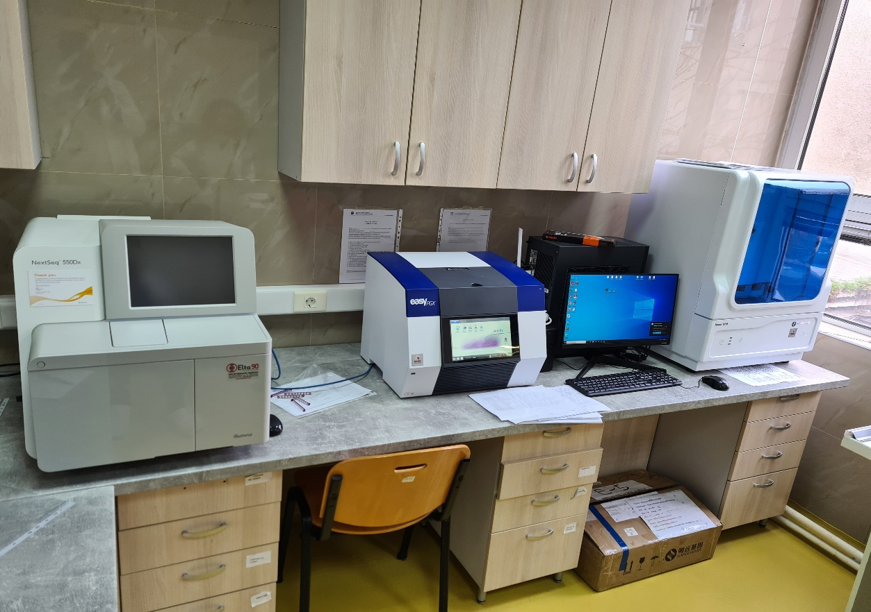

- Introduction of Next Generation Sequencing (NGS) technology to increase the research capacities of the Genetic Laboratory at the Institute of Forensic Medicine, Criminalistics and Medical Deontology of the Faculty of Medicine in Skopje /Project line 3/In the field of Medical Sciences and Health
Project leader: Prof. Dr. Aleksandar Stankov
Principal investigator: Prof. Dr. Zlatko Jakovski
Email: drjakovski@gmail.com
Purchase price: 16,467,550.00 denar (11,547,550.00 denar contribution of the Ministry of Education and Science, 4,950,000.00 denar own funds)
Laboratory description: The implementation of the new sequencing technology offers the possibility of using the latest technological advances in the field of genomics from several aspects: forensic medical aspect - by increasing the capacities for genetic analysis in forensic investigations, as it allows for the simultaneous examination of numerous genetic identification markers (genes, STRs, SNPs, indels) in a short timeframe, and will enable rapid action by the relevant institutions such as courts, prosecutor's offices, attorneys, police, individual persons, etc.; medical genetic aspect - by increasing the capacities for simultaneous analysis of multiple genes and gene panels, thereby contributing to the prevention and precise diagnosis; applicative and international character - the accreditation of the methods tested with the instrument will lead to the increased applicative activities of the Institute of Forensic Medicine, Criminalistics, and Medical Deontology, as well as to international acknowledgement of the results.
Users include doctoral candidates from the country and abroad, while users of the research results include public sector institutions that perform activities in the field of education and science, health, the security sector, and private individuals requesting analyses.
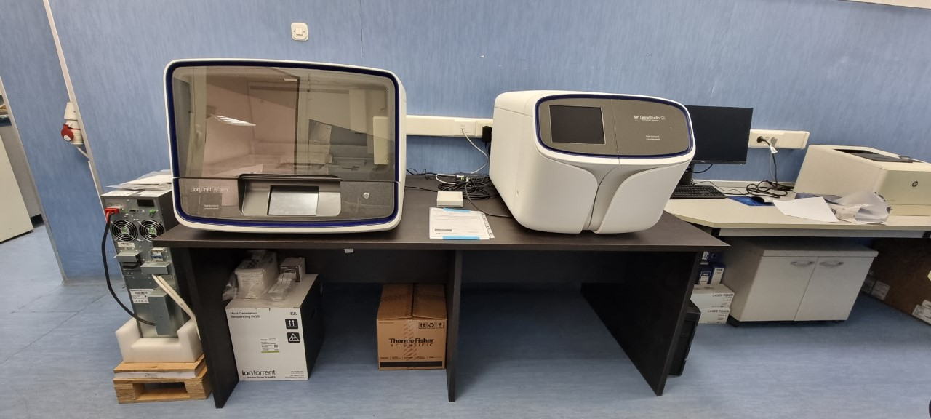

- Nuclear medicine methods in pre-transplant evaluation of potential kidney donors, in assessment of nephrotoxicity and diagnostics of other reduced-function conditions/ Project line 3/In the field of Medical Sciences and Health
Project leader: Asst. Prof. Dr. Tanja Makazlieva
Email: tmakazlieva@medf.ukim.edu.mk
Purchase price: 8,555,000.00 denar (5,121,685.00 denar contribution of the Ministry of Education and Science, 3,433,315.00 denar own funds)
Laboratory description: Nuclear Medicine Department includes two hybrid SPECT/CT gamma cameras, one provided by the Ministry of Health and co-funded by the Faculty of Medicine (2016) and the other SPECT/CT gamma camera provided with an IAEA grant (2017). In 2021, a dedicated camera for nephrology examinations, a Nephrocam gamma camera, was provided under a project of the Ministry of Education and Science. The addition of a new specialized Nephrocam gamma camera allows for improvement of diagnostic practices, greater availability of nephrology NM examinations in the healthcare routine by increasing the volume of healthcare activities, as well as a significant reduction of the waiting time for relevant examinations. The main research goal is to expand the indication areas of application of nuclear medicine examinations. Possible upgrade with a new PET/CT camera for research purposes.
Users in terms of scientific and research activity include students who prepare their papers, master's and doctoral theses. The laboratory infrastructure also contributes to increased competitiveness and is accessible to external researchers, junior researchers and other interested parties for educational purposes.
The Institute of Pathophysiology and Nuclear Medicine is a unit of the Faculty of Medicine and applies the access policies and procedures that apply to the Faculty of Medicine, as part of UKIM.

- Accreditation of a medical laboratory: challenges and opportunities/ Project line 2/In the field of Medical Sciences and Health
Project leader: Prof. Dr. Katerina Tosheska-Trajkovska
Email: tosheskatrajkovska@gmail.com
Purchase price: 1,840,800.00 denar (977,000.00 denar contribution of the Ministry of Education and Science, own funds 863,800.00 denar)
Laboratory description: Institute of Medical and Experimental Biochemistry owns a fully automatic biochemistry analyser based on the photometry principle, with a built-in ISE module, an immunology analyser based on the CLIA technique, an immunology analyser based on the ELFA technique, an immunology analyser based on the fluorescence principle and Europium nanoparticles, a haematology analyser, an electrolyte analyser based on the potentiometric principle, a coagulometer, a biochemistry analyser with an ELISA module. The institute's overall equipment makes it possible to carry out scientific research, provide healthcare services, and conduct educational activities. The equipment is used for the implementation of scientific and research projects, preparation of doctoral and master's theses and training of residents.
- Faculty of Natural Sciences and Mathematics, University "Ss. Cyril and Methodius"- Skopje, total of 13 funded projects:
1. Upgrade and modernization of the research infrastructure of the Nanomaterials Laboratory and introduction of new methods for characterization of the physicochemical properties of surfaces/ Project line 2/ In the field of Natural Sciences and Mathematics
Laboratory name: Nanomaterials Laboratory
Project leader: Prof. Dr. Biljana Pejova, full professor, Institute of Chemistry
Email: bilana@pmf.ukim.mk
Purchase price: 2,999,999.00 denar (100% contribution of the Ministry of Education and Science)
Laboratory description: The research infrastructure of the Nanomaterials Laboratory has been upgraded, which includes the installation of a new scanner, as well as additional operating modes of the scanning probe microscope (SPM), making the final configuration correspond to the SPM 9700 HT model (Schimadzu Co.). The previous configuration, as a separate platform, can be used as a scanning tunneling microscope (STM). The new scanner (HP Scanner) is characterized by a maximum scanning range: 10 mm x 10 mm x 1 mm and an improved control system that, in combination with the new software, allows measurements to be performed in a much shorter time. The obtained results are characterized by improved resolution, which is of particular interest in the study of nanostructured materials. The operation of the new scanner is relatively simple and, following a precisely defined procedure, it could be replaced with the existing scanner if the need arises to map a surface that is outside its range. The existing scanner is characterized by a maximum scanning range: 30 mm x 30 mm x 5 mm.

2. Expansion of the computational capacity of the Computer Laboratory for Theoretical Chemistry and development of new methods for predicting the mechanical properties of pharmaceutical crystals and their polycrystalline aggregates, as well as for calculating the electronic structure and predicting the properties of functional materials/Project line 2 /In the field of Natural Sciences and Mathematics
Laboratory name: Computer Laboratory for Theoretical Chemistry
Principal investigator: Prof. Dr. Ljupcho Pejov
Email: ljupcop@pmf.ukim.mk
Purchase price: 2,985,920.00 denar (100% contribution of the Ministry of Education and Science).

Laboratory description: Additional servers (that function as compute nodes) have been acquired, along with data storage devices, a separate cabinet that houses them and is equipped with a cooling system, devices for an uninterrupted power supply, and a separate console. The compute nodes have been installed, equipped with the LINUX operating system, and their functionality has been tested. As a result, the Computer Laboratory for Theoretical Chemistry has enhanced and expanded its research and computing capabilities. The computing infrastructure of the Computer Laboratory for Theoretical Chemistry has been upgraded. For high-performance computing in the Laboratory, four new servers built on Intel Xeon technology have been purchased and installed as additional compute nodes in the current computer cluster. Two additional uninterruptible power supply systems and a separate console for administration of the additional servers have also been added to the system. The expanded and modernized capacity of the Laboratory was used to conduct a series of research activities on the structure and mechanical properties of a number of crystalline substances pertinent to the pharmaceutical industry (pharmaceutical crystals) have been conducted.
Users: Many staff members, all Institute of Chemistry students, especially those preparing undergraduate, master's and doctoral theses, students of other Institutes at the Faculty of Natural Sciences and Mathematics Skopje, and students of other faculties across the nation use the improved computational resources of the Computer Laboratory for Theoretical Chemistry. The project has an evident potential to provide research services for the economy, as well as for government agencies, public institutions, and other organizations and individuals, including pharmaceutical companies, companies that produce advanced functional materials, and companies in the food and beverage sector.
3. Re-equipping of the Food Microbiology Laboratory - MICRO NUTRI LAB/ Project line 3/In the field of Natural Science and Mathematics, Biotechnical Sciences
Principal investigator: Prof. Dr. Natalija Atanasova-Panchevska
Email: natalijaap@gmail.com
Purchase price: 424,682.00 denar (254,809.00 denar contribution of the Ministry of Education and Science, own funds 169,873.00 denar)

Laboratory description: Four instruments were purchased: Humimeter RH2 (water activity meter) is a laboratory instrument for determining water activity (aw value) of food. It must be taken into account that it is not suitable for juices (syrup), acidic food (such as vinegar) or food and beverages containing alcohol; Device for inspection of the efficiency of cleaning in rooms - Lumitester. This device detects organic substances, residues of body fluids, microorganisms, on various surfaces and in liquids, as well as skin cells. The time between applying the sample and the obtained result should not be longer than 25 seconds and the results are expressed in relative light units. The device has a built-in option for internal calibration; Dry air sterilizer. The dry sterilizer is only suitable for objects that can withstand temperatures up to 220°C, more precisely, only objects made of refractory materials, such as steel, glass, porcelain, ceramics and porcelain or vitreous enamel can be sterilized with dry sterilization: for example, medical instruments, hypodermic needles, cannulas, etc. Only dry objects can be placed in the sterilizer; Bacti–Cinerator incinerator. Bacti-Cinerator sterilizer is a gasless, flameless sterilizer for use with inoculating loops and needles. Sterilization is accomplished through infrared heat source or an inductive source. The electric heat source additionally mitigates the typical hazards associated with personnel safety, specifically by eliminating the need to work with an open flame. This effectively reduces the risks of dangerous or infectious splashing of microorganisms, as well as the potential for cross-contamination.
4. Modernization and development of the Laboratory for Structural Characterization of Materials/Project line 2/In the field of Natural Sciences and Mathematics
Laboratory name: Laboratory for synthesis and analysis of materials
Principal investigator: Prof. Dr. Miha Bukleski
Email: mihabukleski@pmf.ukim.mk
Purchase price: 2,490,179.00 denar (100% contribution of the Ministry of Education and Science)
Laboratory description: The equipment consists of several instruments used in the synthesis and characterization of newly synthesized materials, primarily of the perovskite type (purely inorganic, organo-inorganic, as well as mixed). These include: a Schlenk line for synthesis under inert conditions, a tube furnace with the ability for synthesis at temperatures up to 1200 ºС under vacuum and the ability to control the pressure during synthesis. There is also the possibility of synthesis under inert conditions or in the presence of gas flow. Spin coater for in-situ material synthesis. It is also used to create sandwich (layered) materials, as well as to deposit thin films on a variety of substrates. It can control the temperature and rotation speed of the substrate, thus optimising the conditions under which the synthesis is performed or the thin film applied.
Users: In addition to the unit responsible for laboratory maintenance, which can use the equipment for educational purposes without charge under the terms defined in the Plan for Free Access and Use of the Laboratory, other public state institutions may also use the equipment. In this instance, the equipment is used in line with the plan for the availability of the equipment that was obtained through the awarded research project.
In addition, the laboratory equipment acquired under this project may be utilized indirectly, i.e. through the provision of services to external interested parties. Specifically, the Institute of Chemistry's experts have the option to perform an analysis and provide the findings to an external interested party. In this case, the costs associated with the engagement of the experts will be calculated in addition to the material costs, in accordance with the submitted list of preferential prices of services.
5. Improving the capacity and competence of the Laboratory for Chromatographic Analysis for the analysis of organic pollutants in the environment/Project line 2/In the field of Natural Sciences and Mathematics, Technical and Technological Sciences
Laboratory name: Laboratory for Chromatographic Analysis
Principal investigator: Prof. Dr. Marina Stefova
Email: marinaiv@pmf.ukim.mk
Purchase price: 2,983,721.00 denar (100% contribution of the Ministry of Education and Science).
Laboratory description: Chromatography is a separation technique used for the analysis of organic substances in complex matrices. Gas and liquid chromatography are complementary techniques for separation, identification and quantification, with gas chromatography being used for volatile compounds and liquid chromatography for all other soluble compounds. Separation by gas chromatography coupled with various types of detectors (mass spectrometer, flame ionization detector and electron capture detector) can be used for the identification and quantification of: - volatile and semi-volatile compounds in the environment, pharmaceutical products, food packaging, etc.; - pesticides, persistent organic pollutants (POPs) and endocrine disruptors present in the environment and food. High-performance liquid chromatography coupled with UV-Vis and mass spectrometry as a detector can be used for the identification and quantification of: - polyphenols in plant-based foods, wine, medicinal plants, honey, etc., - active substances and impurities in pharmaceutical preparations, - various pollutants, persistent organic pollutants (POPs) and endocrine disruptors present in the environment and food, - explosives, drugs and other compounds of interest in forensics, etc.
Users: The research infrastructure will be available to students of the first, second, and third cycles of studies in chemistry, biology, and physics, whose respective curricula contain subjects involving the analysis of environmental samples using chromatographic techniques. The instruction will be conducted with the assistance of individuals who have been trained to operate the equipment and use the proper methods, based on the project leader's prior approval.
The equipment can also be used for educational purposes for students of other organizational units (whose respective curricula include the analysis of environmental samples using modern chromatographic techniques), based on the prior conclusion of a cooperation agreement, which will define the provision of consumables.

6. Introduction of standard methods for improving the capacity of analytical student laboratories and training of competent personnel for the economy and institutions/Project line 2/In the field of Natural Science and Mathematics
Laboratory name: Laboratory for Analytical Chemistry and Instrumental Analyses
Principal investigator: Prof. Dr. Jasmina Petreska Stanoeva
Email: jasmina.petreska@pmf.ukim.mk
Purchase price: 2,985,926.00 denar (100% contribution of the Ministry of Education and Science)

Laboratory description: The research infrastructure includes basic laboratory equipment, the utilization of which facilitated the implementation of standardized analytical monitoring methods, as follows: Water analysis - Determination of pH (MKC EN ISO 10523:2013); Water quality - Determination of electrical conductivity (MKC EN 27888:2007); Determination of chloride - Silver nitrate titration with chromate indicator (Mohr's method) (MKC ISO 9297:2007); Determination of calcium content - EDTA titrimetric method (MKC ISO 6058:2007); Determination of the sum of calcium and magnesium - EDTA titrimetric method (MKC ISO 6059:1984); Determination of nitrogen, nitrite (spectrophotometric) (EPA 354.1); Determination of ammonium - Manual spectrometric method (ISO 7150-1); Determination of acrylamide and acrylonitrile by high performance liquid chromatography (HPLC) (EPA 8316). Honey analysis: Determination of electrolytic conductivity, Determination of pH, Determination of Hydroxymethylfurfural by HPLC, Determination of reducing sugars (Harmonised methods of the International Honey Commission, 2009), Determination of individual polyphenolic compounds by HPLC (own method, https://doi.org/10.7546/CRABS.2022.02.05). Analysis of fruits, fruit products and teas: Determination of total polyphenol content (Method OIV-MA-AS2-10, alternative ISO), Determination of total anthocyanins (AOAC 2005.02), Determination of individual polyphenolic compounds by HPLC (own methods, https://doi.org/10.3233/JBR-210717, https://doi.org/10.1177/1934578X20934675, https://doi.org/10.1002/cbdv.202201149). Analysis of fried products (potato chips, coffee): Determination of acrylamide by HPLC/MS (AOAC Official Method 2019). Analysis of parameters of admixtures for concrete, mortar and grout: Determination of the alkali content of admixtures (MKS EN 480-12:2007) and Determination of water-soluble chloride content in admixtures for concrete, mortar and grout (MKS EN 480-10:2009).
Users: Access to the equipment for educational purposes for students of the first, second and third cycle of studies in chemistry, biology and physics, whose respective curricula include subjects involving the application of instrumental techniques for analytical purposes. The equipment is also used for scientific research and application purposes.
7. Improving the capacities for scientific research, teaching and applied activities of the Laboratory for Molecular Biology at the Faculty of Natural Sciences and Mathematics in the University "Ss. Cyril and Methodius" - Skopje/Project line 3/In the field of Natural Sciences, Biology, Molecular Biology
Laboratory name: Laboratory for Molecular Biology and Genomics
Principal investigator: Prof. Dr. Sasho Panov
Email: sasho@mt.net.mk
Purchase price: 19,275,274, denar (13,551,357.00 denar contribution of the Ministry of Education and Science, 5,723,917.00 denar own funds from other funding sources - donation)

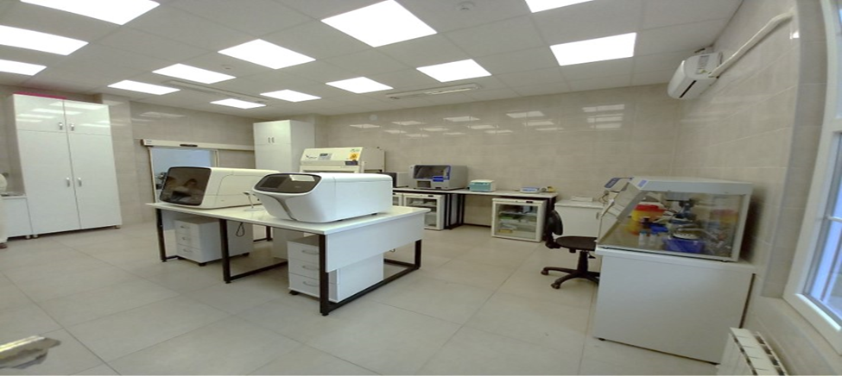
Laboratory description: The Laboratory uses appropriate molecular analyses that include detection of gene variants (point mutations and single nucleotide polymorphisms) based on DNA sequencing, SNaPshot genotyping and enzymatic digestion with restriction endonucleases, detection of different types of gene variants, including insertions/deletions, gene copy number variations, as well as identification of gene fusions based on NGS sequencing, quantitative determination of gene expression by real-time amplification and detection (qRT-PCR), fluorescent in situ hybridisation (FISH), different variants of PCR amplification and other techniques. The isolation of nucleic acids (genomic DNA, total cellular RNA, mRNA and viral RNA) from various biological materials (swabs, blood, tissues, etc.) is performed using automatic extractors, as well as with manual methods. The quantification of the isolated nucleic acids is performed using a fluorimeter. In a certain period, genetic engineering techniques were also applied (construction and purification of plasmid vectors for transient transfection of mammalian cells, electroporation, cloning in bacterial cells, etc.), culture of cell lines in a flow-through CO2 incubator, among others.
The majority of scientific and research activities are in the field of biomedical issues, specifically focusing on the molecular genetics of cancer and the molecular-genetic aspects of complex, polygenic and prevalent cardiovascular, cerebrovascular, neurological and other diseases in the human population.
Users: Internal users include employees and students of the third cycle of studies at the Institute of Biology, Faculty of Natural Sciences and Mathematics, UKIM - Skopje, while external users are state, private, international universities, non-governmental organizations, private companies, etc.

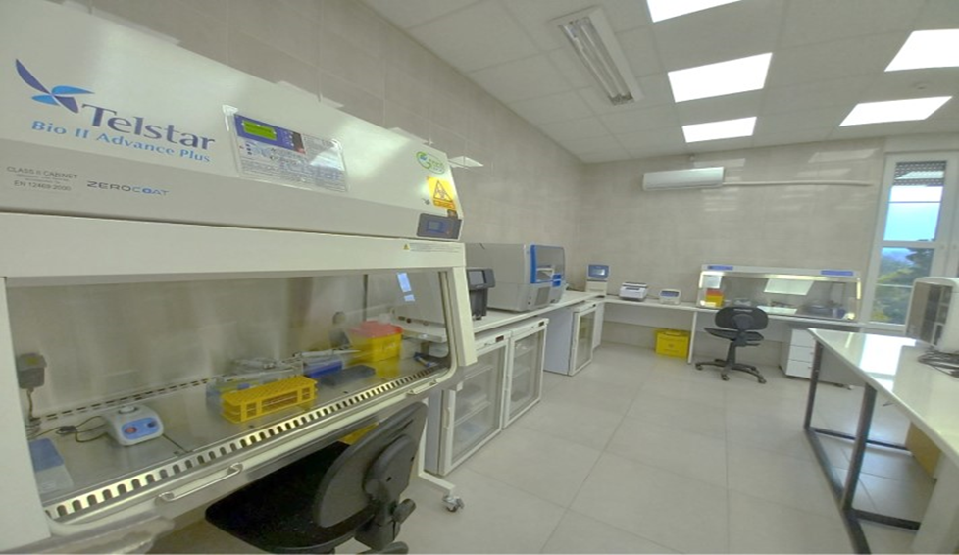

8. Development of the Thin Film Laboratory/Project Line 2/In the field of Natural Sciences and Mathematics
Laboratory name: Thin Film Laboratory
Principal investigator: Prof. Dr. Atanas Tanushevski
Email: atanas@pmf.ukim.mk
Purchase price: 1,832,977.00 denar (100% contribution of the Ministry of Education and Science).

Laboratory description: The Thin Film Laboratory at the Institute of Physics will produce thin films using two new methods, the spin casting method and the rf magnetron sputtering method. Thin films can be semiconductors, insulators, metal electrodes and polymers. For this purpose, a 6/8 inch SPC-80 spin deposition apparatus has been purchased to produce thin films using spin casting. RF generator of 13.56 MHz and magnetron with a diameter of 5.08 cm, for magnetron sputtering of targets and obtaining thin films in solid state of semiconductors, insulators, metal electrodes and polymers. These materials are applied in solar cells to convert sunlight into electricity and as dielectrics in memory devices. This will open up new avenues of research into solar cells, memory devices, sensors, and energy conversion. For characterisation and testing, a device for measuring intensity of sunlight (Solar Power Meter 400-1100 nm + Datalogger) will be used. The solar power meter will allow measuring the intensity of sunlight, as well as performing laboratory exercises in the subject Electronics and testing of solar cell characteristics. BIOBASE® UV/VIS BK-S380 spectrophotometer. The BIOBASE® UV/VIS BK-S380 spectrophotometer is used to analyse the optical characteristics of films, in the range of 190-1100 nm. BALZERS BA 510 vacuum evaporator for depositing thin films by thermal evaporation of materials. Direct current (DC) magnetron for the deposition of thin films in the form of oxides and metals.
Users: The equipment in the Thin Film Laboratory can be used by employees of the Institute of Physics and other institutes of the Faculty of Natural Sciences and Mathematics, employees of the organizational units of the University "St. Cyril and Methodius", employees of other public higher education and scientific research institutions, as well as employees of private higher education and scientific research institutions in the Republic of North Macedonia.
9. Introduction of new bioanalytical methods and development of standard techniques for analysis of amplicons obtained by polymerase chain reaction (PCR) for detection of the presence of SARS- Cov-2/ Project line 2/In the field of Natural Science and Mathematics
Laboratory name: Laboratory of Experimental Biochemistry
Principal investigator: Prof. Dr. Natasha Ristevska
Email: natasa@pmf.ukim.mk
Purchase price: 2,610,390.00 denar (100% contribution of the Ministry of Education and Science).

Laboratory description: The research infrastructure covers the analysis of proteins and nucleic acids in a variety of samples, including: - Separation, qualitative and quantitative determination of proteins in biological samples; - DNA and RNA extraction from viruses, plants and food; - Virus detection in biological samples; - Plant species identification by genome; - Verification of food and beverage origin and authenticity by genome.
Users: Students of the first, second and third cycle of studies in chemistry and biology, whose curricula include subjects and chapters involving the application of chemical methods in experimental biochemistry will have access to the equipment. Based on the previous conclusion of a cooperation agreement that will specify the manner of providing consumables, students of other organizational units that are part of UKIM (whose curricula include subjects and chapters involving the application of chemical methods in experimental biochemistry) may also use the equipment for educational purposes.
Access to the equipment for research purposes: The equipment can also be used for research purposes. Colleagues from the Institute of Chemistry will be able to use the equipment without charge, while colleagues from other units will be able to use the equipment after concluding a cooperation agreement that defines the terms and conditions. Staff members of the Institute of Chemistry who have received the necessary training to operate the instruments can conduct some of the analyses for free, and the results of these analyses should be published in pertinent journals. Also, some analyses can be conducted for an adequate fee in line with the defined "Preferential prices for services".
Access to the equipment for application purposes: The project leader and participants may also use the equipment for application purposes. An agreement between the two parties will specify the terms under which the services will be rendered.
10. Modernization of the Infrared Spectroscopy Laboratory/Project line 2/In the field of Natural Sciences and Mathematics
Laboratory name: Infrared Spectroscopy Laboratory
Principal investigator: Prof. Dr. Petre Makreski
Email: petremak@pmf.ukim.mk
Purchase price: 3,241,662.00 denar (2,941,971.00 denar contribution of the Ministry of Education and Science, 299,691.00 denar own funds)

Laboratory description: Currently, this is the Institute of Chemistry's oldest laboratory. It is the foundation of scientific and research work of the majority of the Institute of Chemistry's staff members. Thus, it is available to any Institute of Chemistry member who shows an interest in working with infrared spectroscopy, including students, master's students, doctoral candidates, and research staff. Most of the publications of the Institute of Chemistry were prepared through this laboratory, directly or indirectly. Currently in use in the lab is a Perkin-Elmer System 2000 FTIR infrared spectrometer, which was acquired in 1995 and is nearly thirty years old. This instrument, which represented the height of technology at the time, needed an upgrade and therefore with the help of numerous donations, accessories were acquired to enable the recording of low-temperature spectra, specular reflectance, polarized radiation, diffuse reflectance (DRIFT), attenuated total reflectance (ATR), and absolute reflection (with integrating sphere). With the purchase of a new Perkin Elmer tri-range Spectrum 3 FT-IR spectrometer in 2022 through the MES project for laboratory equipment, the lab is now equipped with an infrared spectrometer that enables it to continue operating without interruption.
Users: In addition to the scientific research activity of the laboratory, it offers application in the following areas: the pharmaceutical industry (analysis of the composition of medicines, and more recently also of hemp oils), the construction industry (analysis of various types of coatings), the food industry (analysis of oils and other food products), the polymer industry (polymer composition analysis), etc.

11. Re-equipping the Laboratory for Chemical Surface Modification and introducing new methods for measuring contact angle and zeta potential in specific systems/Project line 2/In the field of Natural Sciences and Mathematics
Principal investigator: Prof. Dr. Vladimir Ivanovski
Email: vladimir@pmf.ukim.mk
Purchase price: 2,999,999.00 denar (100% contribution from the Ministry of Education and Science)
Laboratory description: The Laboratory for Chemical Surface Modification is concerned with the modification of the material surface through chemical means to achieve the desired properties without intervening in the material's overall properties. Any glass surface that can be chemically treated to become hydrophilic or hydrophobic (with the goal of creating self-cleaning glass) without losing its transparency or other qualities serves as an example. The modified surfaces analysis is performed applying molecular-spectroscopy techniques (Infrared and Raman spectroscopy), contact angle measurement using an optical goniometer and additional surface energy calculation, as well as determination of charge of colloidal systems.
Users include researchers (academic staff, professors, assistant professors), junior researchers, teaching assistants, senior laboratory assistants who are employed at the Faculty of Natural Sciences and Mathematics, as well as those who are not. Additionally, the Laboratory provides applied activities for domestic businesses.
In terms of the access policies of this research infrastructure, the Faculty has adopted an Access Policy Document and provides free access for the use of the Laboratory for educational purposes.

12. Introduction of standard physics tests for primary education and a teaching support system/Project line 2/In the field of Natural Sciences and Mathematics
Principal investigators: Prof. Dr. Oliver Zajkov
Email: zoliver@pmf.ukim.mk
Purchase price: 1,368,599.00 denar (100% contribution of the Ministry of Education and Science)
Laboratory description: The Laboratory for Teaching Methods of School Experimentation has been in operation almost from the very beginning of the natural science studies at the University “Ss. Cyril and Methodius", initially known as simply the Collection of Equipment, later changed its name to the Laboratory for School Experiments and finally to the Laboratory for Teaching Methods of School Experimentation. The focus of the Laboratory's activities shifted along with its name. The Laboratory has equipment, devices, apparatus and instruments for over 400 experiments that can be used in practically every area of physics instruction at the elementary and secondary school levels.
All individuals and organizations involved in education and education research have access to the infrastructure. Use of the equipment is only permitted if users have previously received training from qualified experts who are Laboratory members, as well as under the supervision of authorized experts and mentorship for specialized scientific research. Under the mentor's supervision, access is granted to laboratory personnel, external partners (both domestic and foreign) engaged in collaborative research and application projects, and students of all three cycles of study to the extent required for their research activities in the course of their studies.
13. Raman spectroscopy of materials/Project line 2/In the field of Natural Sciences and Mathematics
Principal investigator: Prof. Dr. Metodija Najdovski
Email: metonajd@yahoo.com
Purchase price: 1,911,342.00 denar (100% contribution of the Ministry of Education and Science)
Laboratory description: Raman spectroscopy is a spectroscopic technique that relies on the inelastic scattering of monochromatic light generated by a laser. Inelastic scattering occurs when the frequency of photons from monochromatic light changes when they interact with the sample being studied. The sample absorbs photons from the laser light and subsequently emits them. The Raman effect occurs when the frequency of emitted photons is altered (higher or lower) relative to the incident monochromatic frequency. This shift reveals information about the vibrational energy changes in the molecules. The resulting Raman spectra provide detailed insights into the molecular and structural composition of a wide range of materials, allowing for precise identification and characterization through their unique vibrational signatures.
The research infrastructure offers a wide range of services tailored to the specific needs of academic institutions and industry. These services support innovation, quality control and advanced research in the pharmaceutical industry, materials science, geochemistry and mineralogy, nanochemistry, technology development and environmental applications.
The laboratory is open for cooperation with academic, innovation and industrial institutions and companies.

- Faculty of Design and Technology of Furniture and Interior, University “Ss. Cyril and Methodius”- Skopje
Project: Upgrade of the Furniture Testing Laboratory/Project line 2/In the field of Biotechnical Sciences
Project leader and principal investigator: Prof. Dr. Gjorgji Gruevski
Email: gruevski@fdtme.ukim.edu.mk
Purchase price: 3,430,000.00 denar (2,930,000.00 denar contribution of the Ministry of Education and Science, 500,000.00 denar own funds)

Laboratory description: The Furniture Testing Laboratory's primary focus is on the final consumers of furniture. In addition to preventing unnecessary energy loss in buildings, furniture testing protects the final consumers from unintentional harm and deformations of the human body. Apart from furniture, the Laboratory also tests builders’ joinery and carpentry, or examines doors and windows. It is crucial to test facade joinery in order to achieve energy-efficient structures. The trained team, sophisticated equipment, and ongoing quality control ensure tangible results for the tested units.
The Furniture Testing Laboratory is an accredited laboratory that offers quality services to final consumers. For 14 years, the Laboratory has been guided by the principles of availability and confidentiality toward clients, as evidenced by internal inspections, management checks, and assessments by the Institute for Accreditation of the RNM assessment team. External users include manufacturers of windows, furniture, interior doors, glass packages and manufacturers of security (burglar-proof) doors.
- Public Scientific Institution Hydrobiological Institute - Ohrid
Project: Development of a method for detection of mercury in different matrices from aquatic ecosystems/Project line 2 /In the field of Natural Sciences and Mathematics
Project leader: Research associate Elizabeta Veljanovska Sarafiloska
Email: elizabetasarafiloska@yahoo.com, www.hio.edu.mk
Purchase price: 2,122,584 denar (34,514 euro), (funded 100% by the Ministry of Education and Science).
Laboratory description: A mercury detection instrument has been purchased, and a basic method for detecting mercury in diverse matrices has been established. This instrument provides the ability to analyse samples in all aggregate states (solid, liquid and gas), without requiring sample preparation, the ability to analyse samples with a complex matrix, has an extremely low detection limit (up to 0.001 ng Hg), wide working range (0.01 ng-1500 ng Hg), precision of ≤ 1% @ 5 ng Hg and short analysis time (usually 5 minutes).
The Institute does not have an access policy document.
External users: The purchased equipment, the established standard methods, the serviced equipment, as well as the entire existing equipment of the PSI Hydrobiological Institute are available to junior researchers not only from our country but also from the region and from all over the world, which enhances the scientific and research cooperation of the institution with other institutions based on signed Memorandums of Understanding. At the same time, this allows the exchange of research staff from the institutions, i.e. study stays, and preparation of master's and doctoral theses. In addition, it allows for the continuation of the established practice of the PSI Hydrobiological Institute of organizing summer camps (schools), as well as holding thematic practical courses for domestic and foreign students. There is potential for practical application and availability of the laboratory infrastructure for applicative work as well as for educational purposes.

- Public Scientific Institution Institute for Old Slavic Culture - Prilep
Project: "Accreditation and formal recognition of the Laboratory for Archaeometry in the PSI Institute of Old Slavic Culture - Prilep /Project line 1/In the field of Humanities
Project leader: Hristijan Talevski

- Macedonian Academy of Science and Arts (MASA)
Project: Improving the capacity of the National Centre for Genomics and Proteomics at the Research Centre for Genetic Engineering and Biotechnology (RCGEB) - MASA in the field of personalized medicine/Project line 3/In the field of Medical Sciences and Health
Project leader: Academician Aleksandar Dimovski
Email: a.dimovski@manu.edu.mk
Purchase price: 35,949,976.00 denar (17,538,592.00 denar contribution of the Ministry of Education and Science, 18,411,384.00 denar own funds).
Laboratory description: Four devices have been purchased, specifically:
- Instrument for NGS–exome sequencing, NextSeq 550, Illumina
- Instrument for automated preparation of NGS analyses Biomek i5 – Automated workstation, Beckman Coulter. The introduction of next-generation sequencing (NGS) enables the acquisition of information on the entire genome of an individual in a single analysis. The application of NGS primarily enables the introduction of a new personalized approach in the clinical management of malignant and infectious diseases through individually based strategies for diagnosis, prognosis, therapy selection, and treatment outcome monitoring, thereby increasing the success rate in the diagnostics of rare genetic diseases.
- 3500 Genetic Analyser, Thermo Fisher Scientific is a capillary electrophoresis system with simultaneous analysis of a minimum of 8 samples based on fluorescent detection with 6 unique colours.
- QuantStudio Absolute Q Digital PCR System, Thermo Fisher Scientific.
In terms of the education of junior researchers, the equipment has been used by internal employees to conduct research for 3 doctoral dissertations, one for clinical genetics specialization, 4 master's theses. For external users, it has been and will continue to be used for educational activities related to postgraduate studies, specialization and doctoral studies in the field of molecular biology and genetic engineering for postgraduate and doctoral students of the Faculty of Pharmacy, Faculty of Natural Sciences and Mathematics, Faculty of Technology and Metallurgy and Faculty of Veterinary Medicine, as well as specialization students of the Centre, Faculty of Pharmacy and Faculty of Medicine.
Access policies: In compliance with the guidelines for open access to RCGEB-MASA research infrastructure users, the Centre proposes general terms and conditions for collaboration with institutions interested in implementing joint projects or using the RCGIB equipment, depending on their requirements. There are a number of options available for external users to utilize the equipment, including using their own chemicals or chemicals that were purchased by RCGEB-MASA, as detailed in the Rulebook and Price List. These documents have been approved by the administrative bodies of MASA and are available on the RCGEB-MASA website.

External users:
In the country:
- PHI "Zhan Mitrev" Clinic, Skopje
- BIO ENGINEERING DOO export-import Skopje
- Bionica Pharmaceuticals, DOO Skopje
Preparation of master's theses and doctoral dissertations by students of:
- Faculty of Pharmacy - University "Ss. Cyril and Methodius", Skopje
- Faculty of Natural Sciences and Mathematics, UKIM, Skopje
- Faculty of Medicine, UKIM, Skopje
- Faculty of Agriculture, UKIM, Skopje
- Faculty of Technology and Metallurgy, UKIM, Skopje
- Faculty of Veterinary Medicine, UKIM, Skopje
- Faculty of Pharmacy - UGD, Shtip
From the Western Balkans:
- Faculty of Medicine, University of Ljubljana, Slovenia
- GENICA Lab - Genetic and medical diagnostic laboratory, Bulgaria
- Faculty of Medicine, Tirana, Albania
- Faculty of Medicine, University of Belgrade, Serbia
- Vincha - Institute of Nuclear Sciences, Department of Atomic Physics, University of Belgrade, Serbia
From EU and other countries:
- National Institutes of Health (NIH), Columbia University, USA
- International Centre for Genetic Engineering and Biotechnology (ICGEB), Trieste, Italy
- International Atomic Energy Agency (IAEA)

Research Infrastructure website: http://manu-icgib.mk

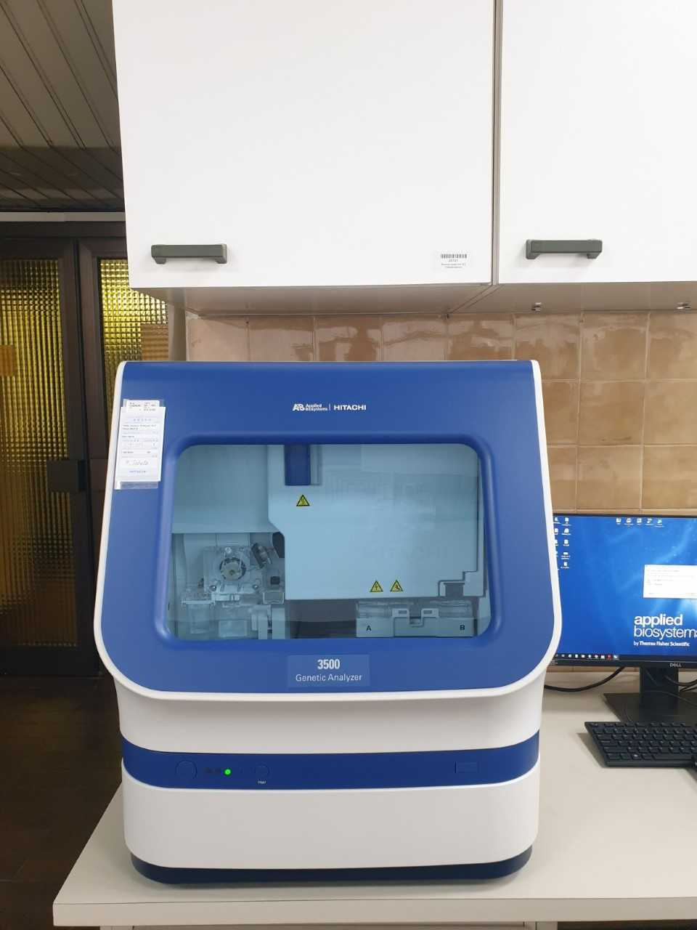
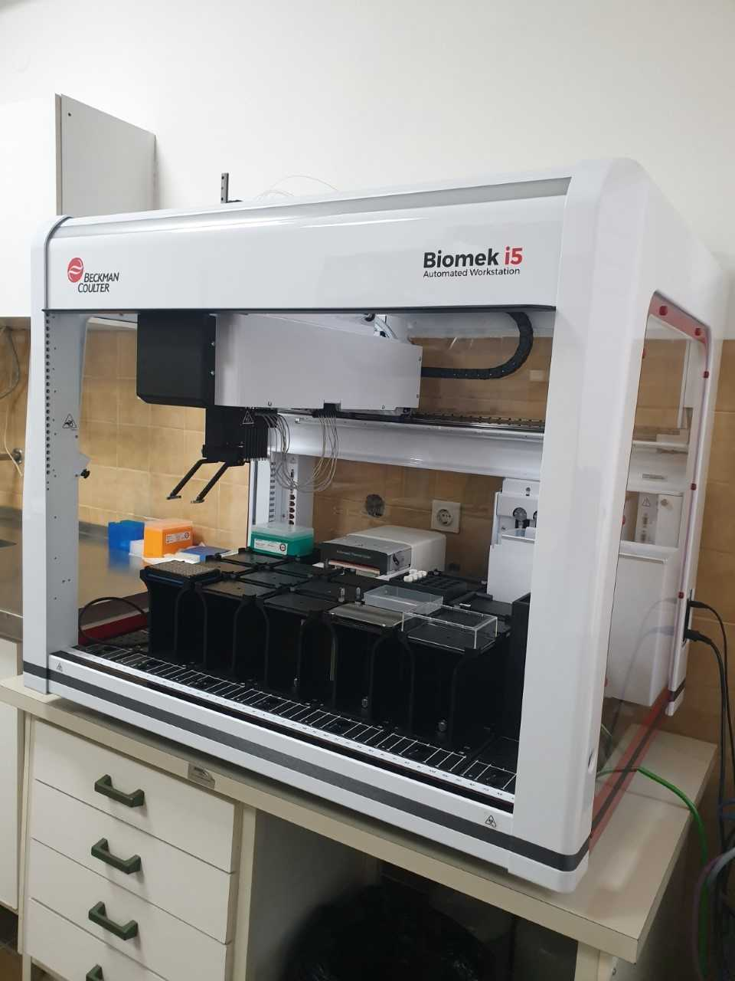

The project has not been implemented.
The project has not been implemented.
The project has not been implemented.

