Newsletter December 2023

December update - Twinning Project “Further support to the implementation of the National Qualifications Framework” funded by the EU MK IPA 17 SO 01 21

Concluding Component 2: Another Contribution to Advance the National Qualifications Framework
We are pleased to announce the official conclusion of the Twinning project in December, marked by a significant activity under Component 2. This phase focused on supporting the further implementation and enhancing the capacities of the National Qualifications Framework (NQF) in alignment with the Quality Assurance (QA) framework.
Under Component 2, the key objective was to enable transparent and simplified procedures and methodologies for the development and inclusion of qualifications/occupational standards from various learning settings in the digital NQF register.
Activity 2.2.5, designed as a "training of trainers," served as a logical continuation of previously implemented activities related to developing qualification standards. The mission aimed to provide detailed information on the organization of approval of qualification standards in Higher Education (HE), referencing of HE to the NQF, quality assurance of HE qualifications, as well as referencing of HE qualifications to the European Qualifications Framework (EQF) and the Qualifications Framework of the European Higher Education Area (QF-EHEA).
The training sessions, conducted from November 27 to December 1, were attended by representatives from Higher Education Institutions (HEIs), colleagues from the Ministry of Education and Science (MoES), and representatives from the Chamber of Commerce.
Lithuanian and Croatian experts, Mr. Vidmantas Tutlys and Ms. Ana Tecilazic, covered a comprehensive range of aspects throughout the mission. Topics included the importance of qualification standards for increasing transparency and comparability, the use of qualification standards in internal and external QA, the significance of leveling HE to NQF, and the referencing of HE qualifications to the EQF and QF-EHEA levels.
In addition to the on-site activities, the experts prepared webinars on the involvement of stakeholders in the development and implementation of NQF and on aligning internal quality assurance systems with NQF.
The collaborative efforts of all parties involved in this Component have resulted in outputs that promise to make the education and training system more transparent and modern, reflecting all developments within the country and beyond.

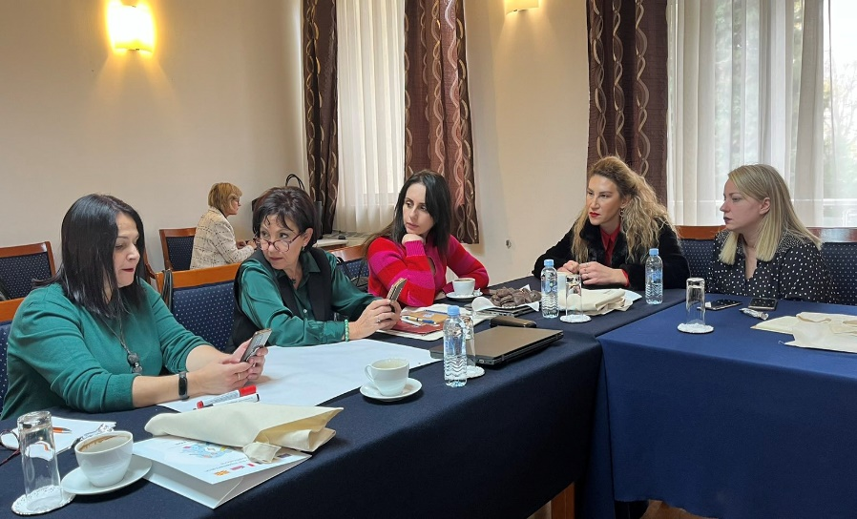
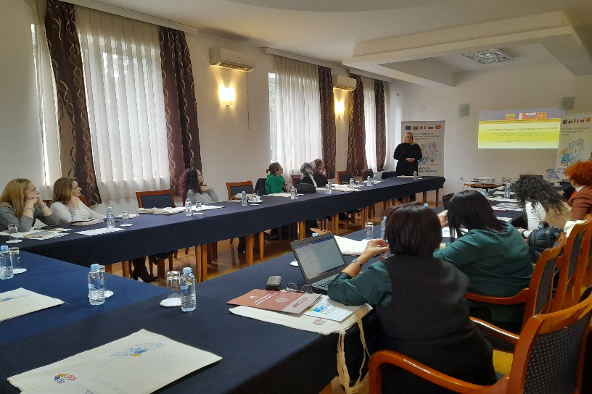

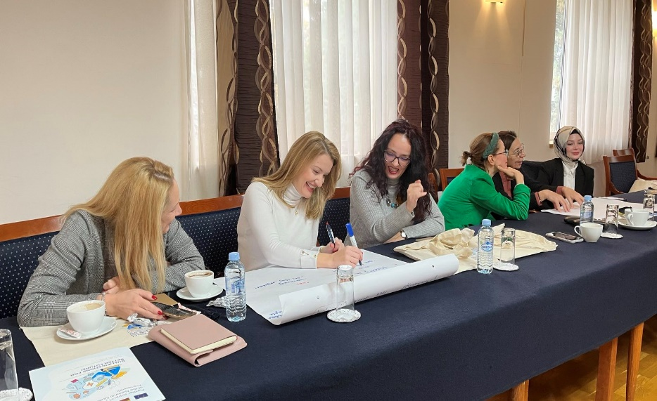

Photos: Activity 2.2.5 “Training of trainers”

Final Steering Committee Meeting to Conclude the Collaborative Efforts of the Partners
The ninth Steering Committee Meeting within the framework of the Twinning project took place on December, 12. Marking the final stage of implementation, this important meeting provided an opportunity for comprehensive overview of the project's achievements during the preceding quarter, but also an opportunity to glance back on the 27 months of project’s implementation. The State Secretary, Ms. Biljana Kazandjiska, extended a warm welcome and expressed gratitude for the individual and collective efforts of all members of the Steering Committee, which is extremely important for the full operationalization of the NQF, thus making it more visible and recognized by the citizens, educational institutions and employers. The foreign experts contributed to the upgrading of the NQF, making it more applicable in many sectors.
The Resident Twinning Advisor (RTA), Ms. Jolita Butkienė, presented the 8th Quarterly Report listing the activities that were successfully realized and the benchmarks met, including information on the engagements of experts and stakeholders. A total of 57 BC representatives from MoES, HEIs, vocational education and training (VET) organizations, NQF Board and other relevant institutions and bodies in North Macedonia participated in the project activities. 31 MS experts dedicated 25 working days to diverse initiatives and concepts that were presented during 7 project events, including workshops and peer-learning activities/training sessions. In addition, 4 project deliverables were completed during the quarter in question: Promotional Campaign Manual, Guidelines on managing and quality-assuring the digital input in the NQF register, as well as NQF promotional materials.
All four MS Component Leaders used the opportunity to elaborate on the implemented activities and reflect on the challenges ahead. Mr. Vidmantas Tūtlys, CL1, outlined three steps for further NQF development: continuous competence building, implementation of recommendations in selected areas, and monitoring and making adaptations as necessary. Ms. Odeta Kupetienė, CL2, underscored the importance of advancing the implementation of the developed Roadmap, and maintaining a dialogue with stakeholders. Mr. Aleksandar Sladojevič and Ms. Urška Marentič as CL 3 and 4, shared insights into the achievements related to the NQF's digital register and the promotion of NQF, including the success of the international conference for the 10th anniversary of the NQF that brought together over 70 participants. The challenges ahead need to be dealt with concerted efforts to ensure a functional digital register based on EQF recommendations, enabling the country to connect to EU platforms. The Steering Committee Meeting concluded with the formal approval of the 8th Quarterly Report and an invitation for the final event to mark the closing of the Project.

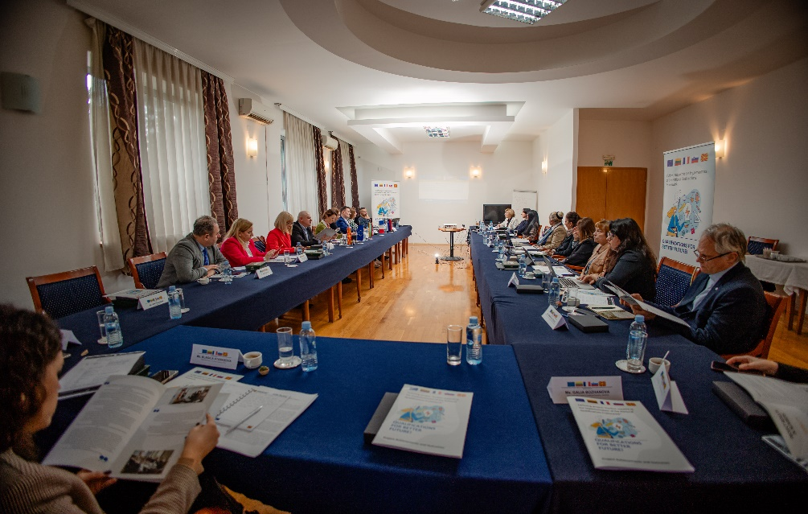
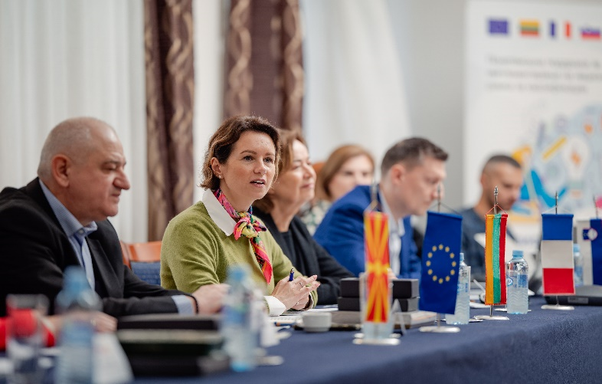

Photos: 9th Project Steering Committee Meeting held on December, 12

Final Event: A Checkpoint for Project Achievements and Challenges Ahead
The official closing ceremony of the project took place on 13th December at the Marriott hotel. The event served as an occasion dedicated to summarizing project's achievements. It welcomed esteemed guests, including dignitaries from various embassies, representatives from the EU Delegation, and members of the media. All main stakeholders, including the project consortium and relevant beneficiary institutions gathered to reflect on the significant milestones attained during the project’s implementation phase.
Started in October 2021, the project has been a collaborative effort over the past 27 months, culminating in the implementation of 36 project activities spanning across 4 components. 40 short-term experts dedicated 802 working days to deliver 113 capacity-building events (peer-learning activities, workshops, focus groups), 10 awareness-raising events and one international conference. They also produced 77 written outputs such as thematic analyses, recommendations, manuals, guidelines, strategic documents and Communication Strategy. Over 1000 participants representing all stakeholders participated in the project’s activities. In addition, comprehensive information and visibility materials were produced and distributed, and 8 media interviews were given for purposes of familiarizing the general public with the topics in question. In this regard, the final event was also used for instigating a positive perception of the education and training system in the country.
The event commenced with welcome addresses by the Minister of Education and Science Jeton Shaqiri, Marie-Madeleine Kanellopoulou representing the EU Delegation, as well as by the Ambassadors of the partner countries: Vilma Dambrauskienė representing Lithuania, Cyrille Baumgartner representing France, and Gregor Presker representing Slovenia. Valuable insights from the process of project implementation were shared by the project`s leadership: Agnė Kudarauskienė in the capacity of MS Project Leader, Michelle Houppe and Aleksandar Sladojevič as Junior Project Leaders and Borcho Aleksov in the capacity of BC Project Leader. The agenda also featured an overview of EQF and EU policies on skills and qualifications by Koen Nomden, a Team Leader representing the European Commission. Bringing the beneficiary perspectives to attention, prof. Tatjana Atanasova Pachemska presented the project benefits for the education system, labour market and society in general. Aleksandar Nikolovski representing the Students’ Union reflected on the major challenges that students are currently facing, and last but not least, Vidmantas Tūtlys in the capacity of Component Leader 1 presented three possible scenarios for further development of NQF: development of open and comprehensive system of qualifications with well-integrated qualifications, development of several very autonomous subsystems of qualifications, or development of completely independent subsystems of qualifications.
The robust social media outreach efforts yielded significant attendance numbers for the final event. The successful culmination of the event met its primary objectives, which included presenting the project outcomes and establishing a collaborative platform for the active participation of all stakeholders. This approach is designed to enhance responsiveness to practical challenges. Subsequently, a press release was issued to apprise the general public, and major news portals in the country have shared the information.
We express our gratitude to all participants, speakers, colleagues and experts for contributing to the success of this Twinning project.
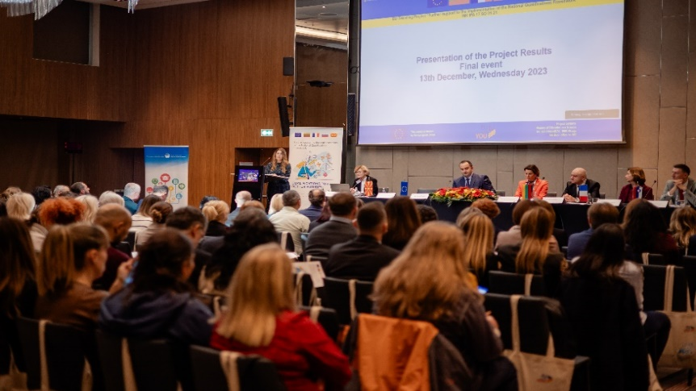
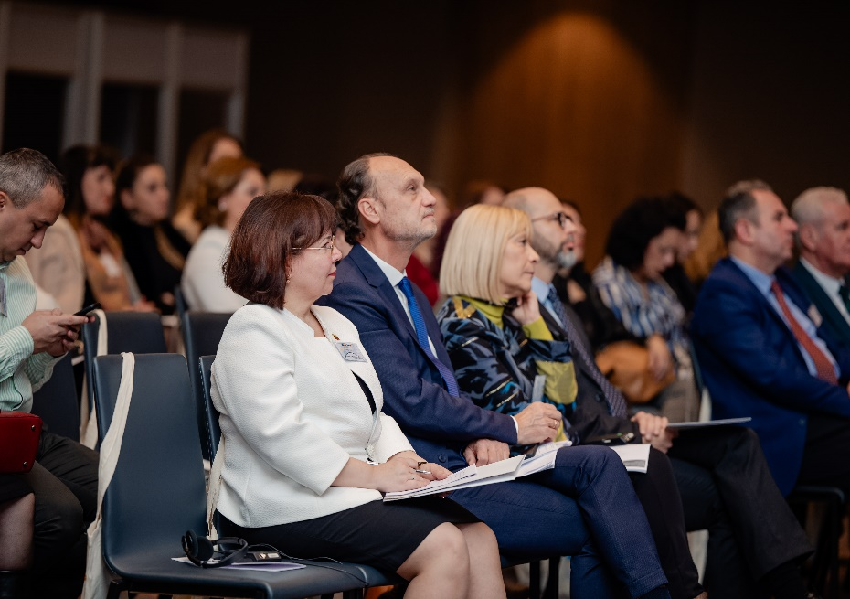
Photos: Final event for presenting project results held on December, 13

This Newsletter was created and maintained with the financial support of the European Union. Its contents are the sole responsibility of the Twinning project and do not necessarily reflect the views of the European Union.

